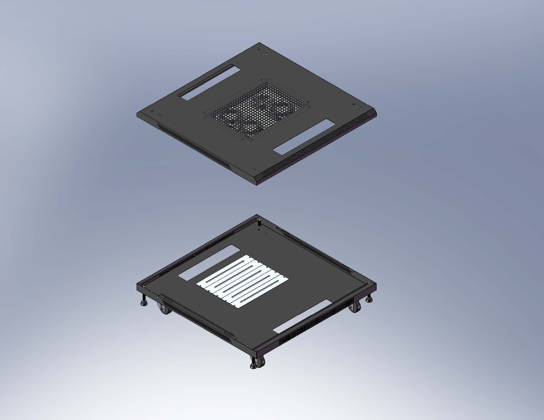  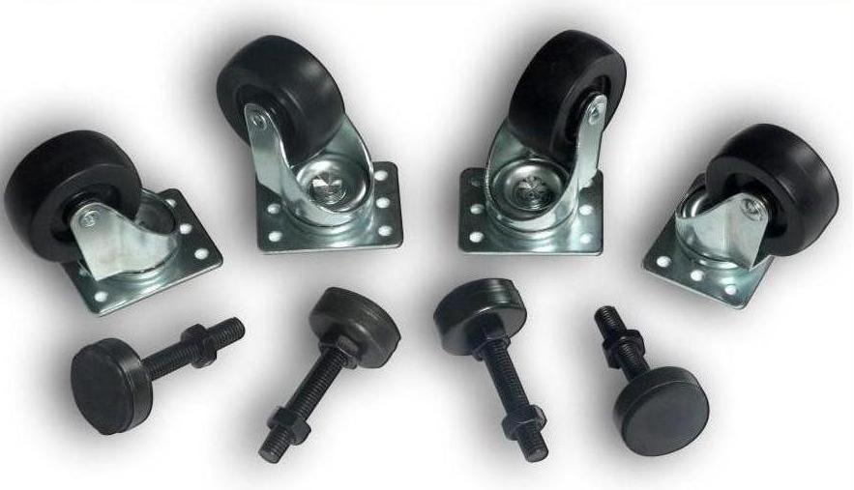 | 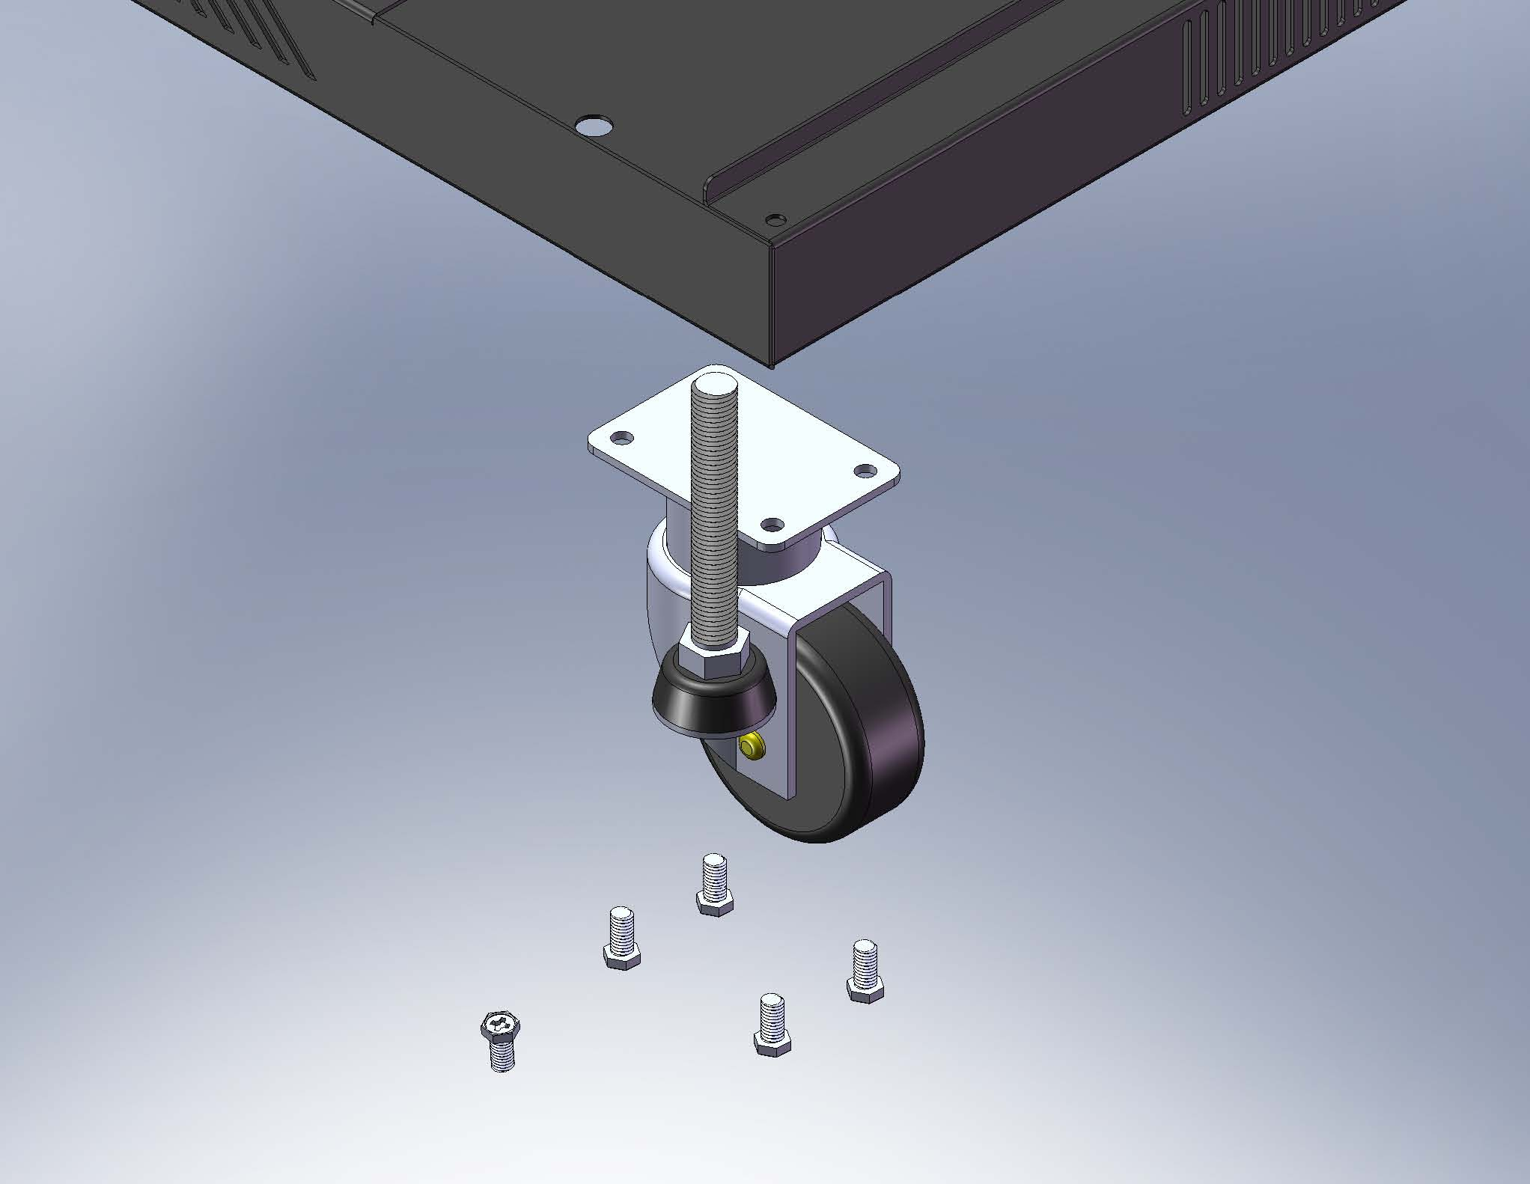 | 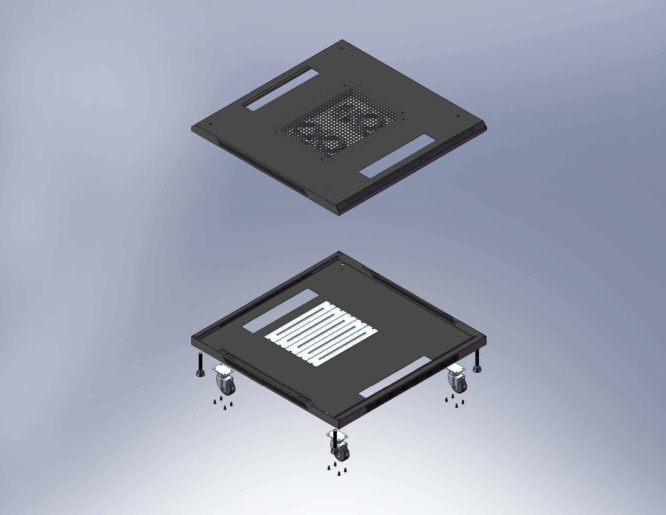
Top and bottom frame, castors, adjustable feet. | Installing castors and adjustable feet. | Finish the assembly.
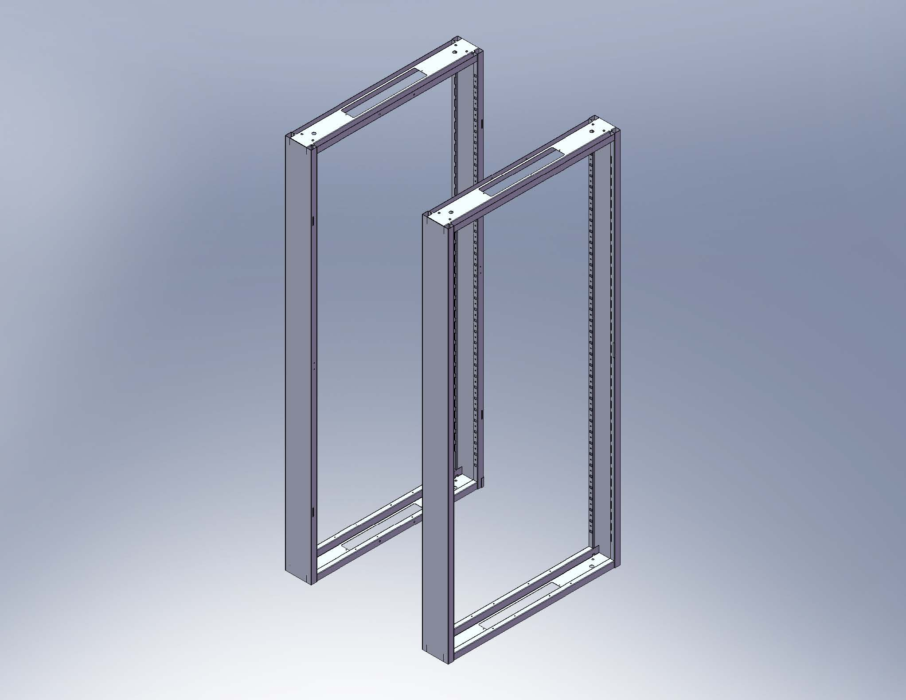 | 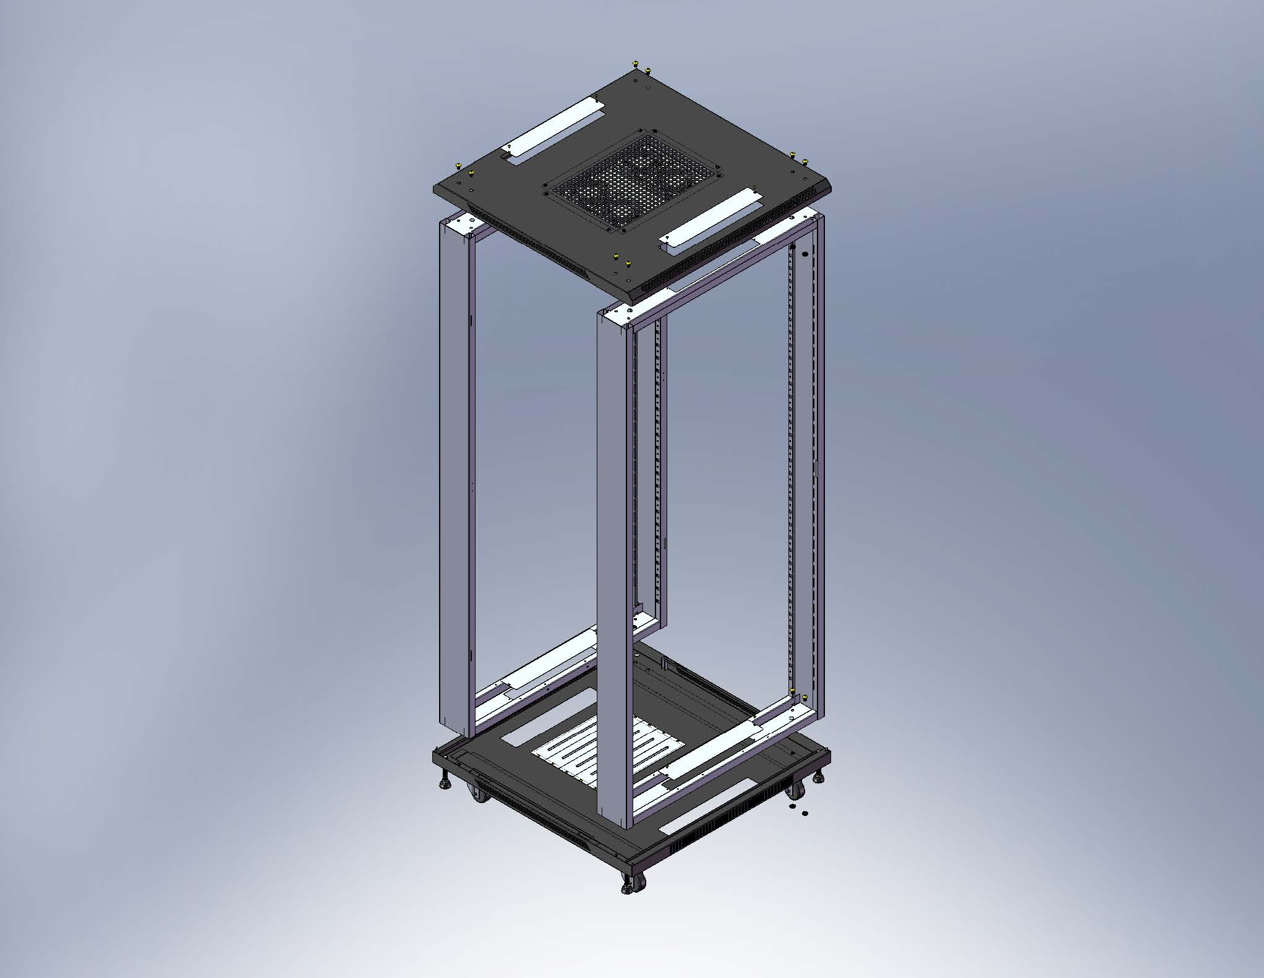 | 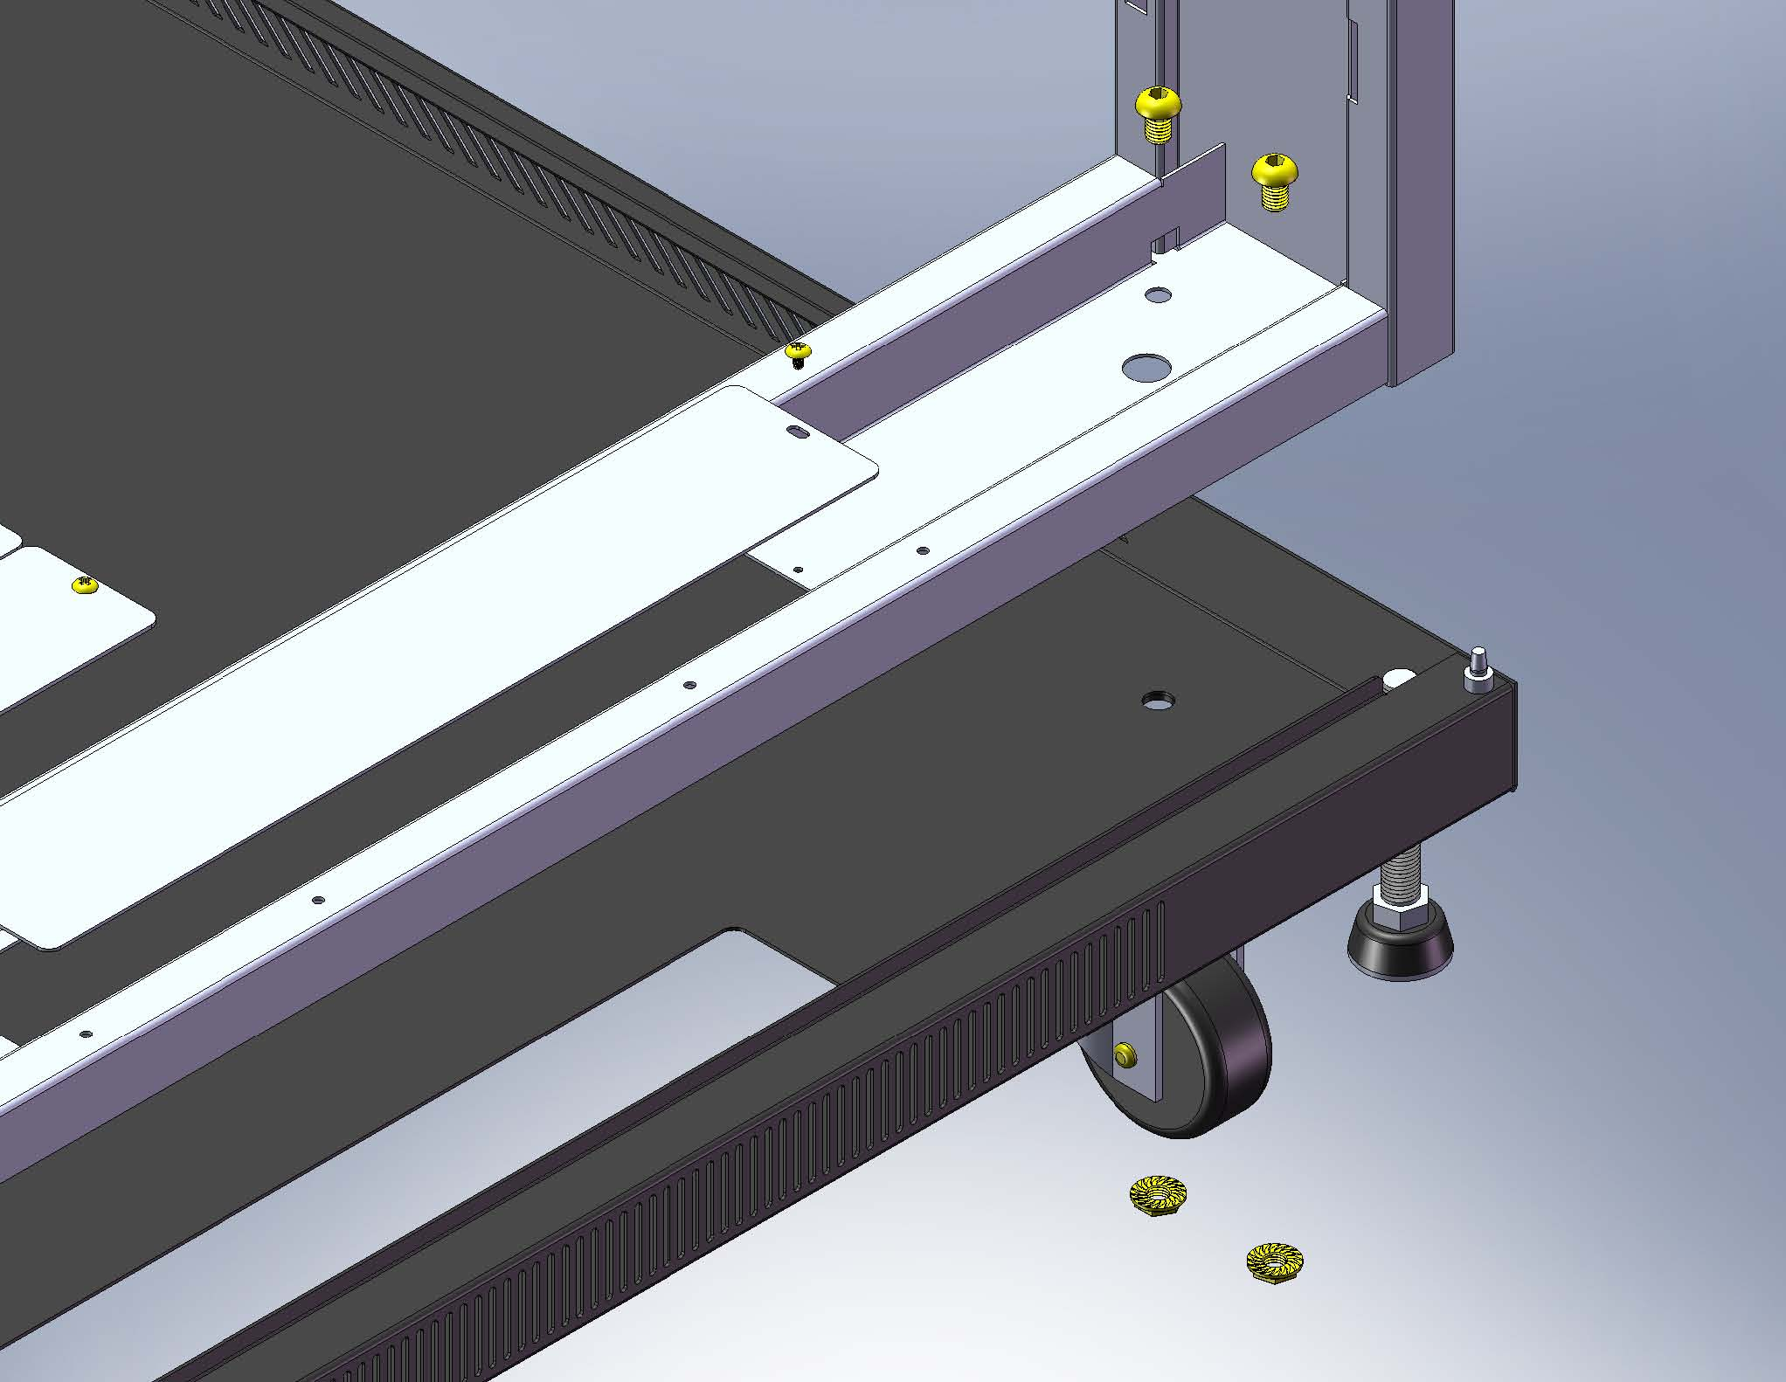
Stand up the front and rear frame. | Inserting the end of the frame into the slots on the top and bottom frame. | Locking the screws
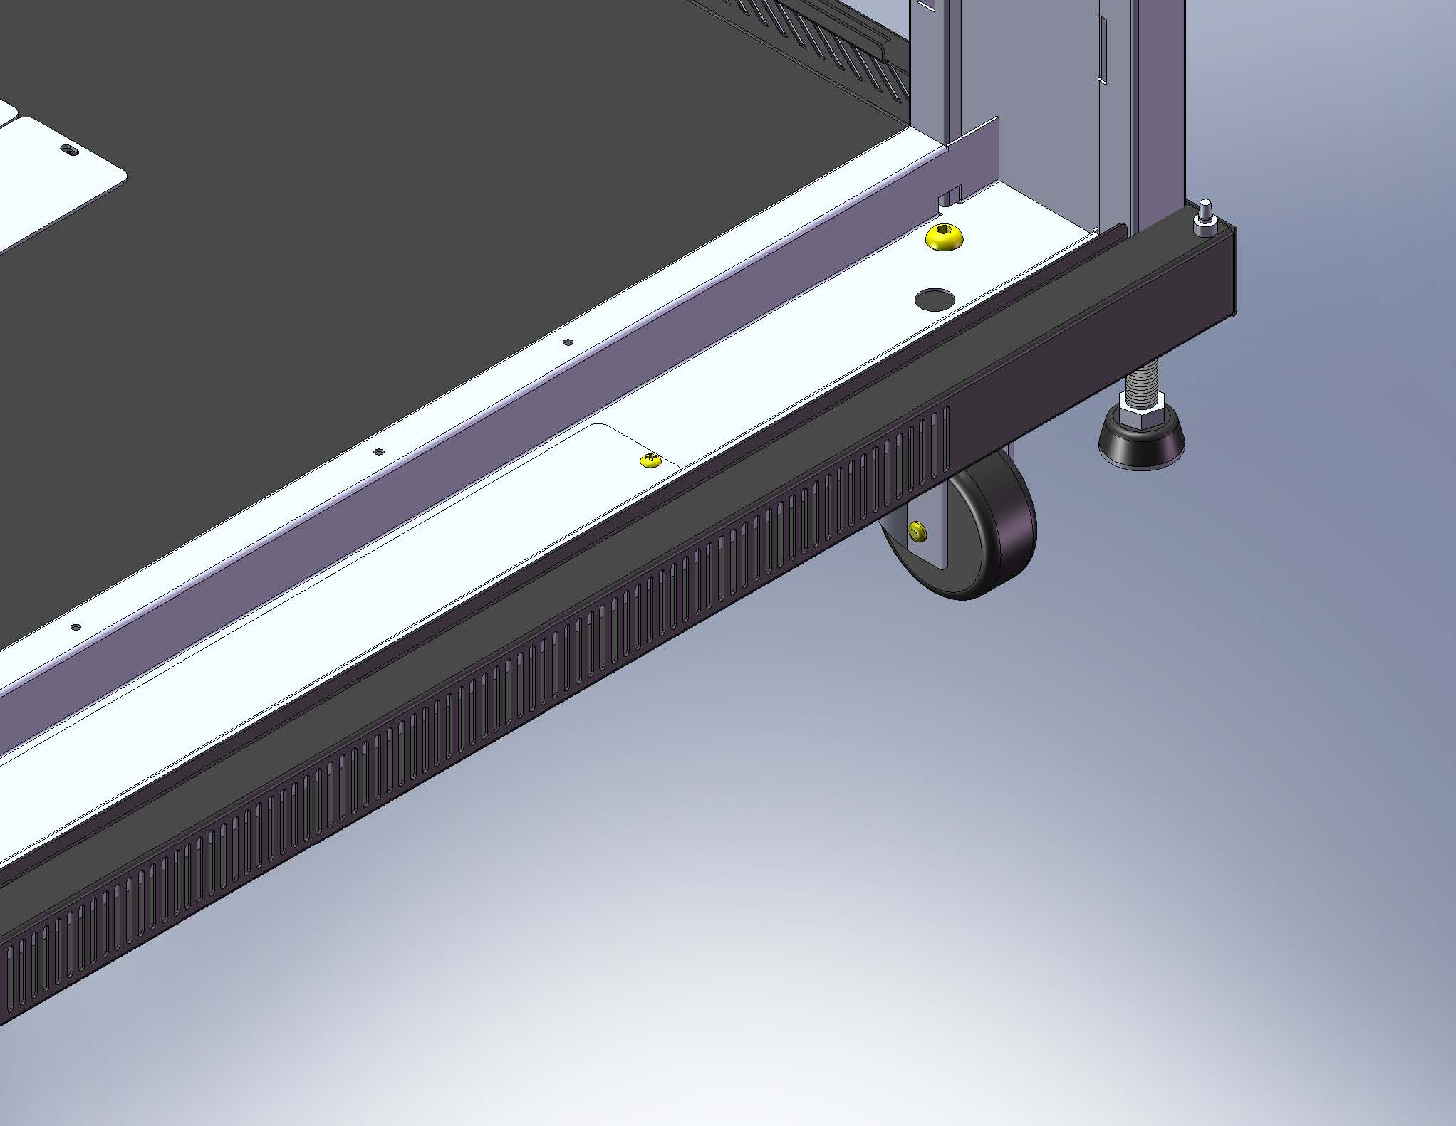 | 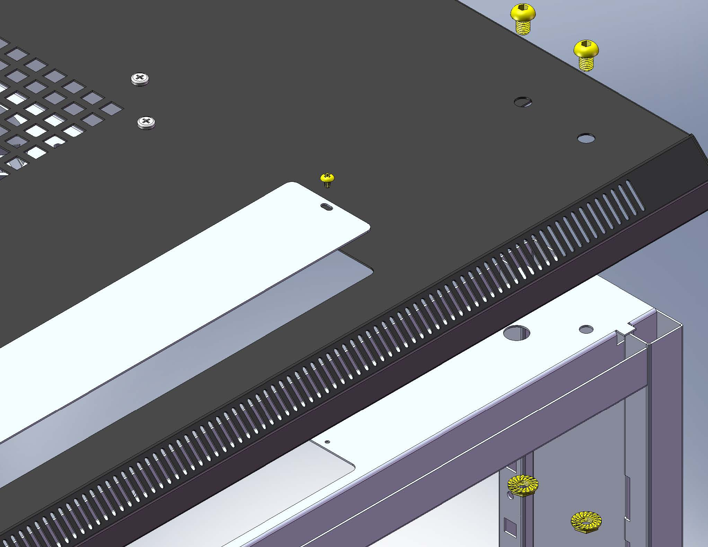 | 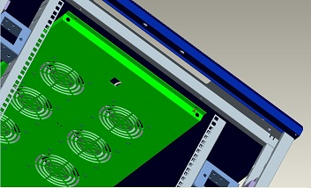
Locking the bottom frame, down-cable management. | Locking the top frame, up-cable management. | Installing the fan tray.
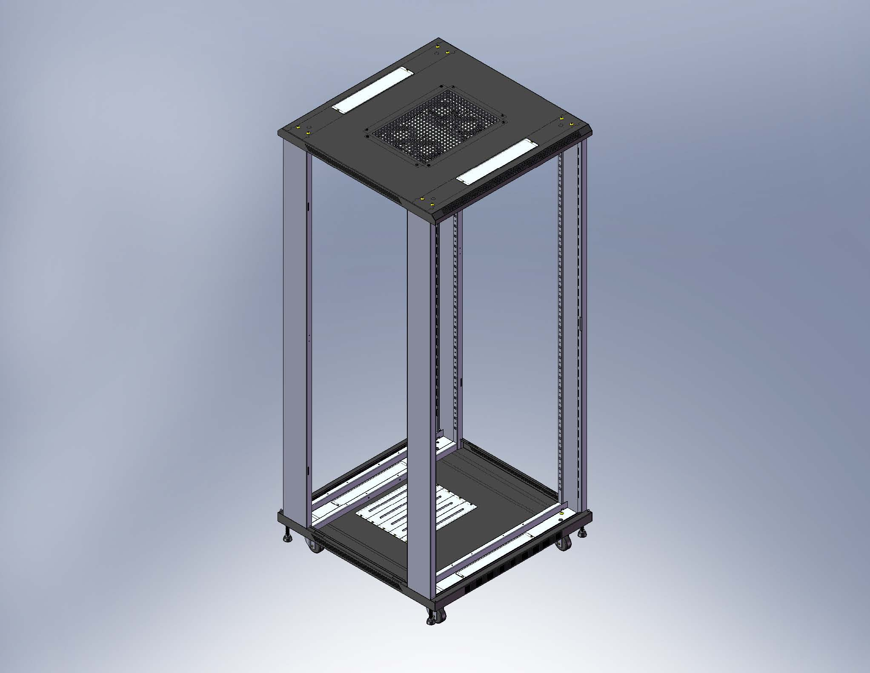 | 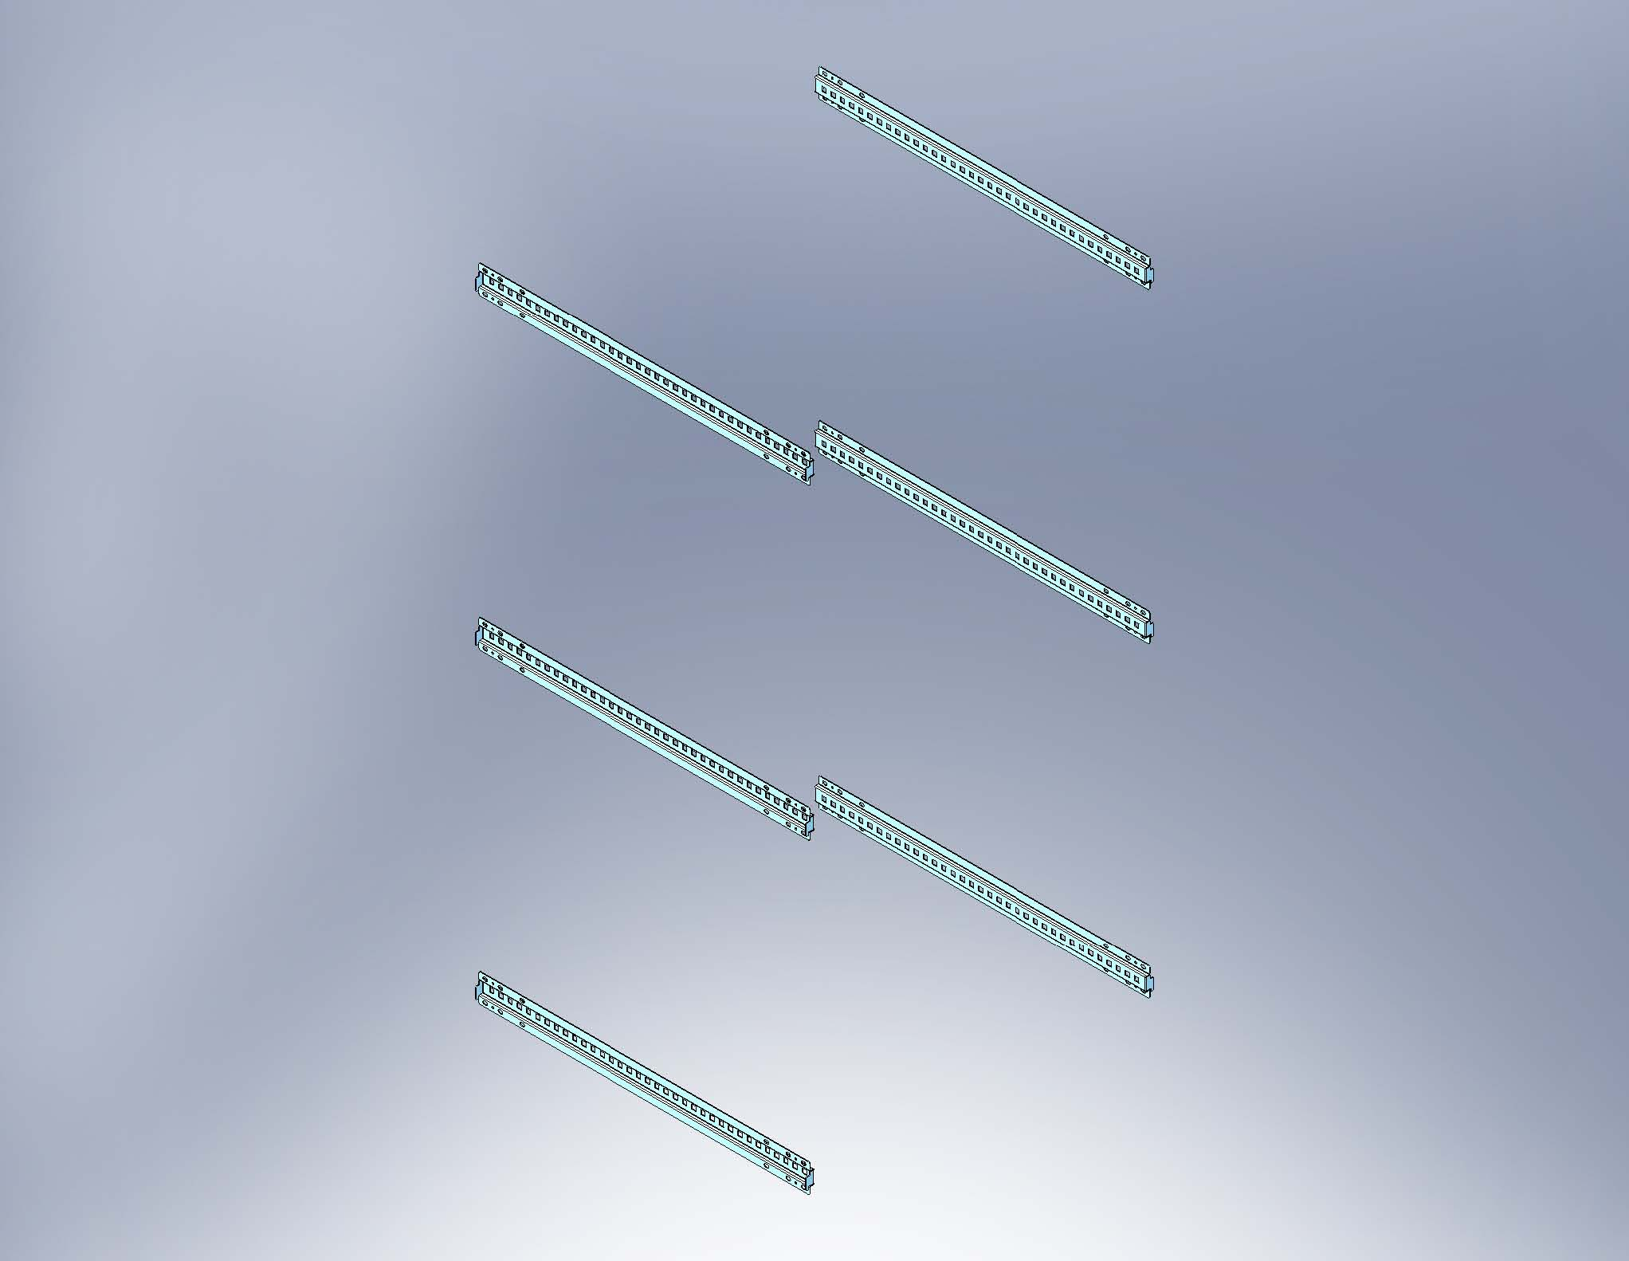 | 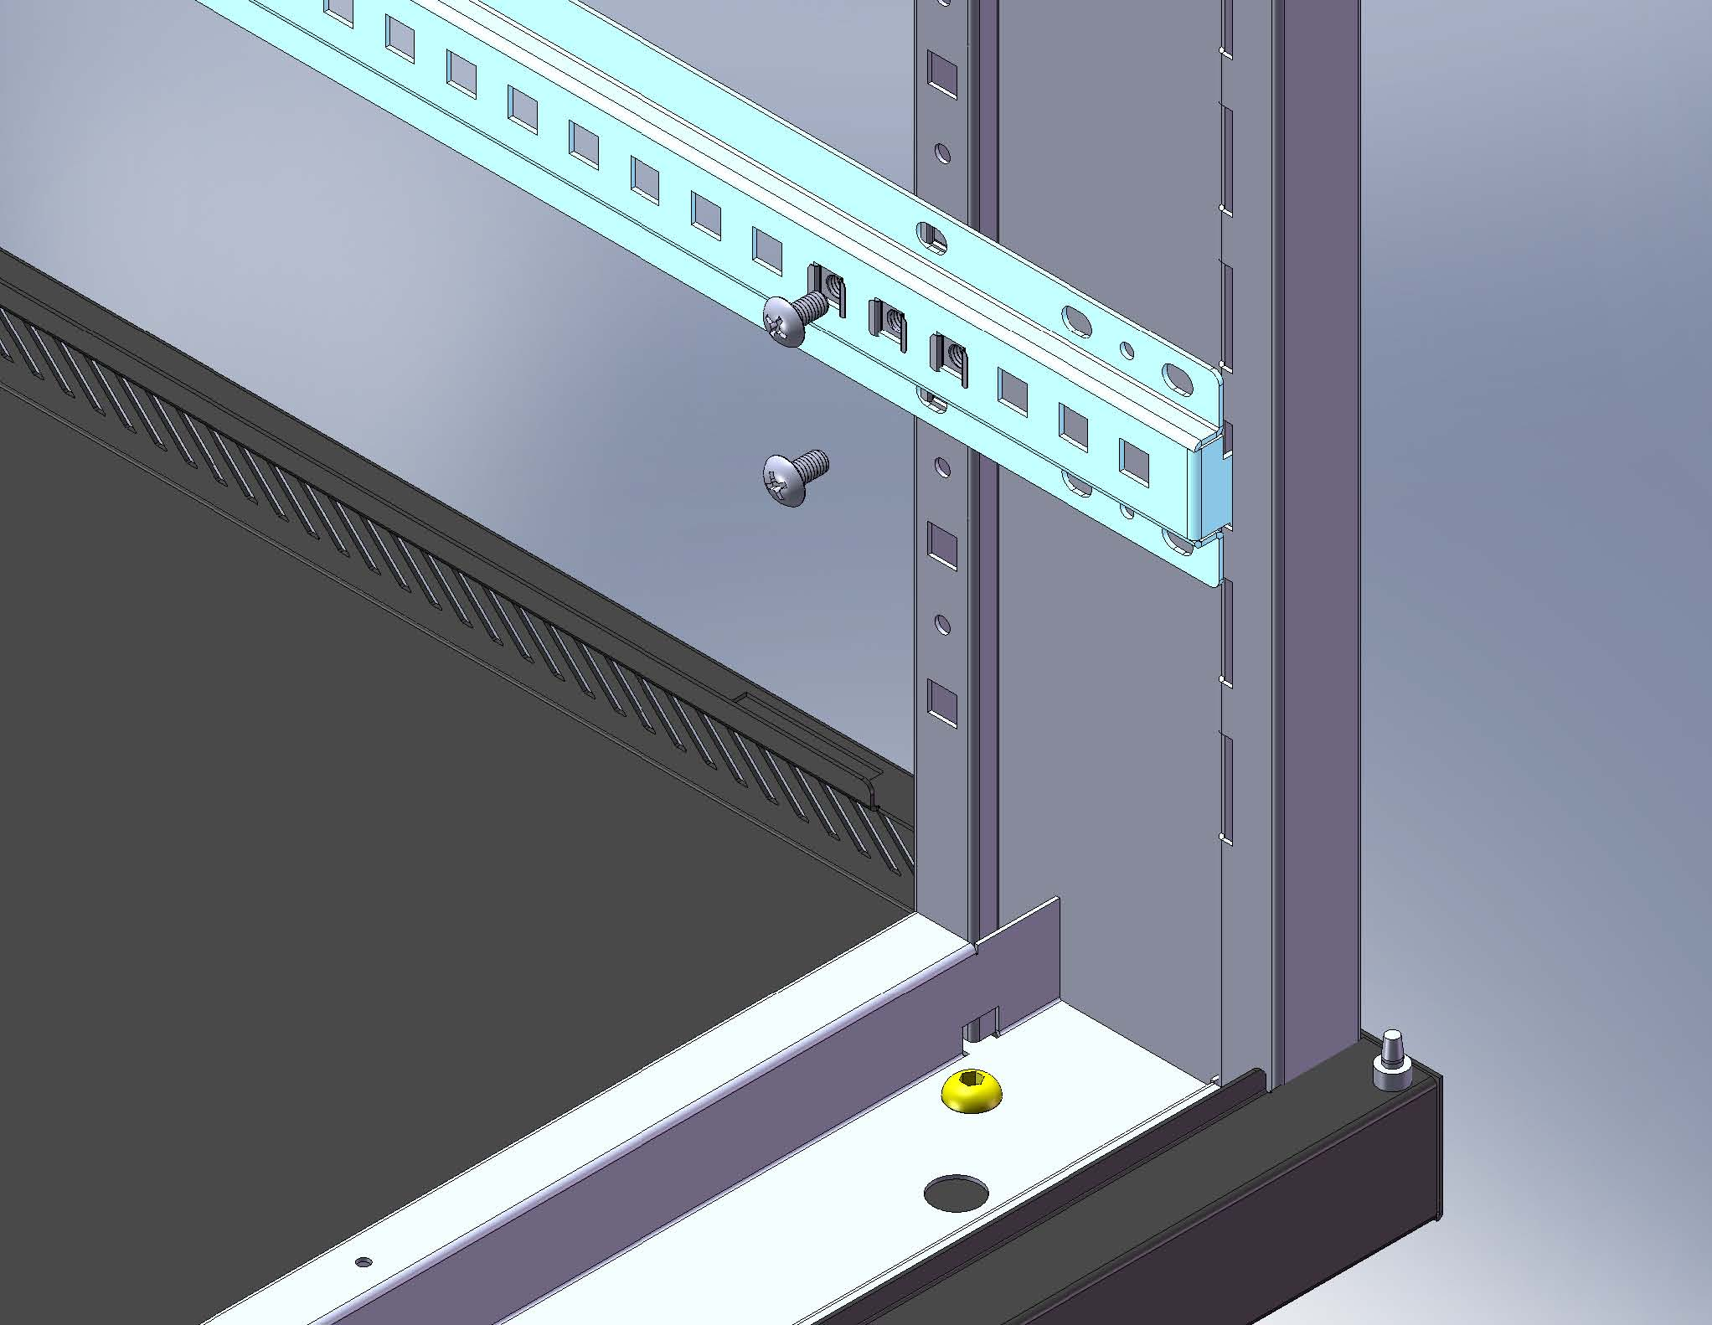
Finish the assembly.  (Main frame, castors and adjustable feet.) | Horizontal mounting Rails.  (Left and right each 3 pcs) | Installing horizontal mounting rails by screws.
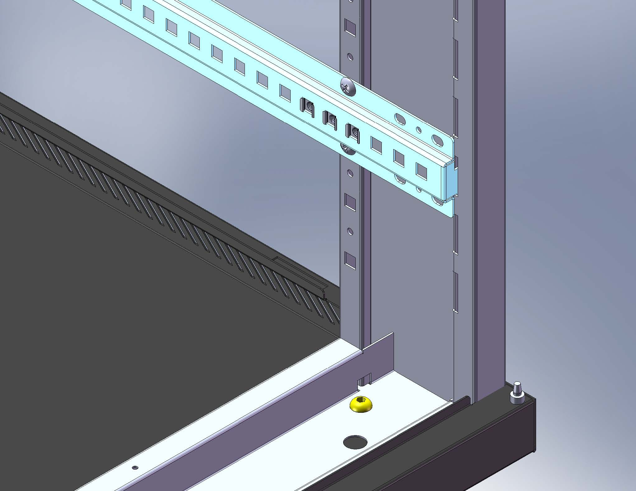 |  | 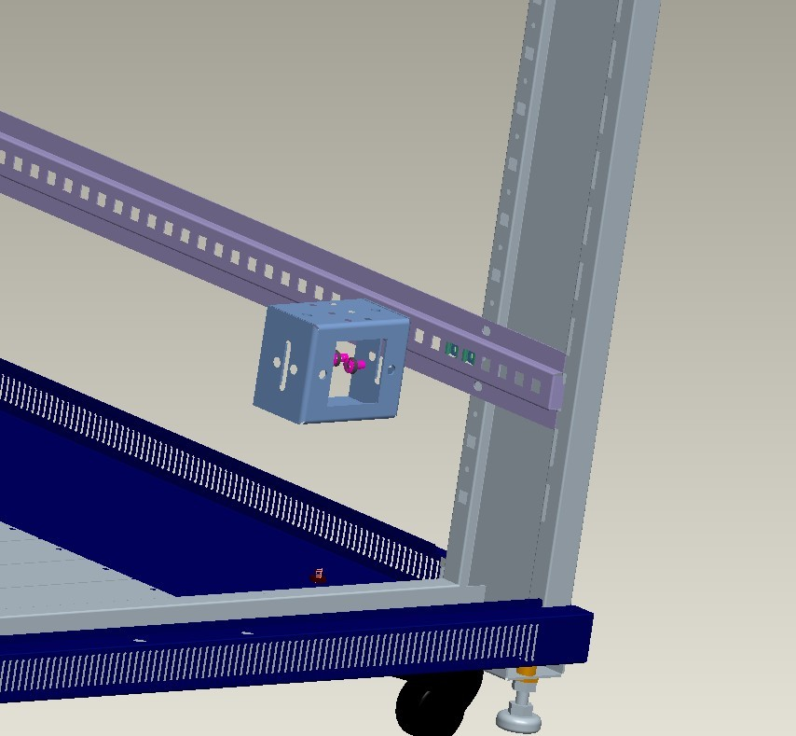
Finish the assembly. | *Only for cabinet width 800 mm* (12 pcs in total of square connector) | *Only for cabinet width 800 mm*  Installing the connector to horizontal mounting Rail by screws.
P03 Series Rack Assembly Guide

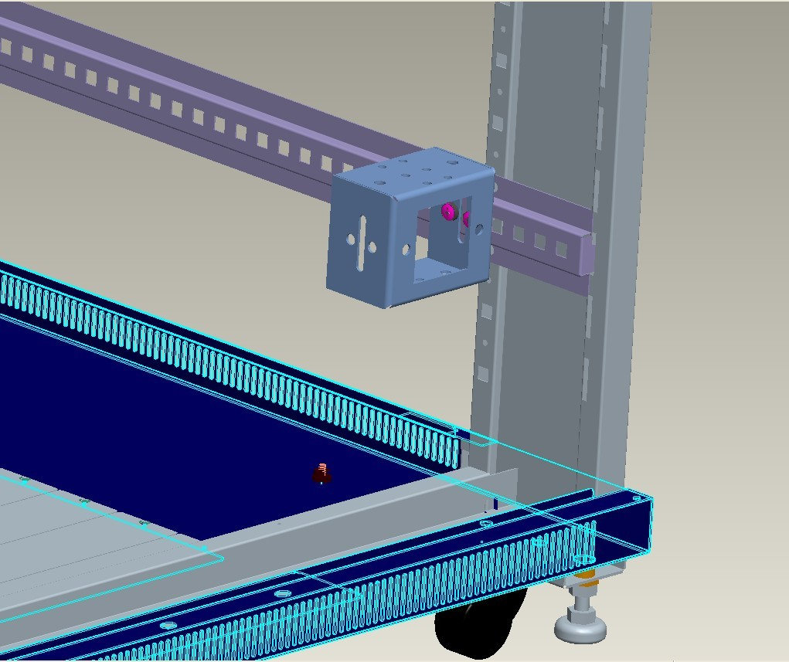 | 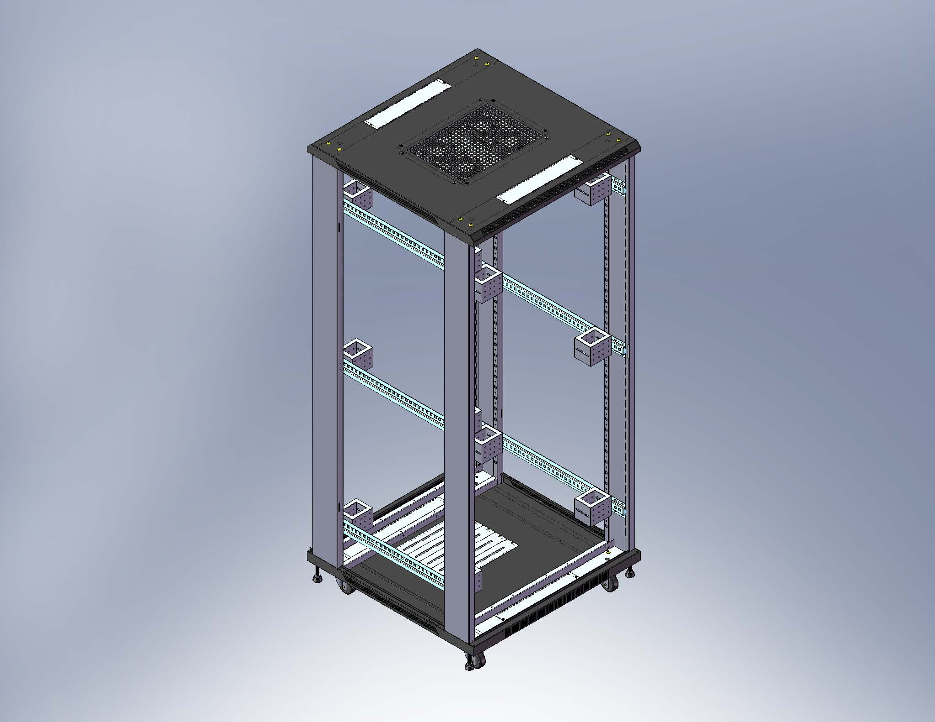 | 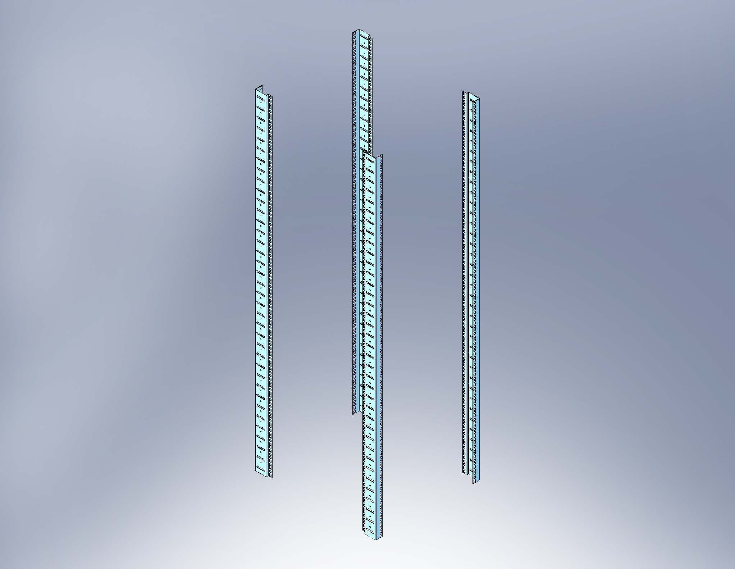
*Only for cabinet width 800 mm*  Finish the assembly. | *Only for cabinet width 800 mm*  Installing the 12 pieces of square connector. | 19’ Vertical Mounting Rail. ( 4 pcs in total)
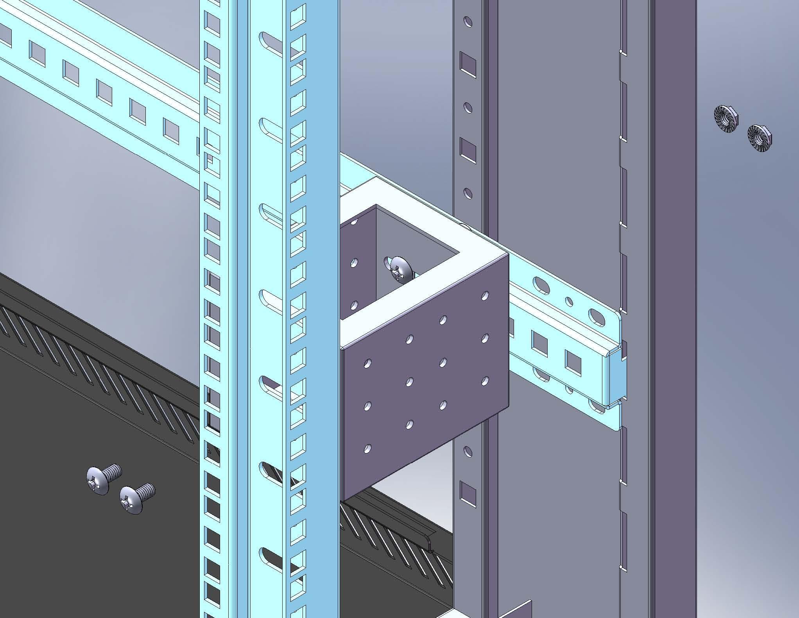 | 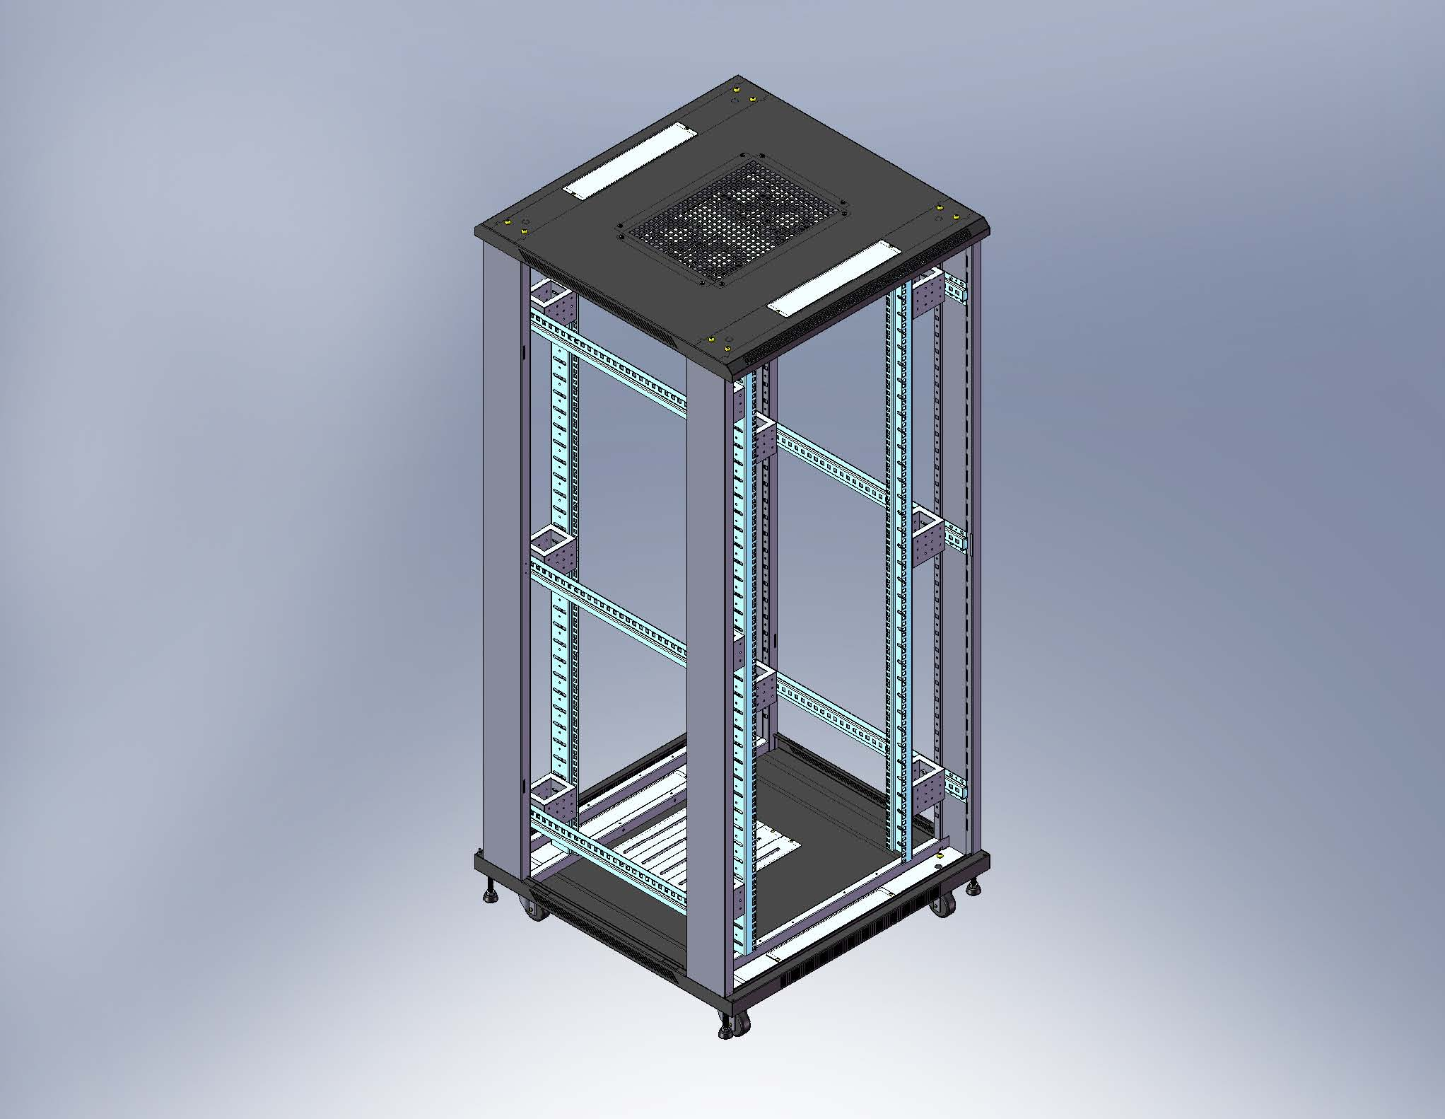 | 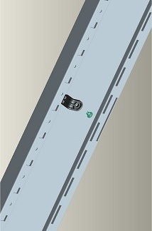
*Only for cabinet width 800 mm*  Installing the Vertical Mounting Angle to Mounting Rail. (The middle part is connector) | *Only for cabinet width 800 mm* | Installing the plastic plug (door stop) on the front frame and rear frame.
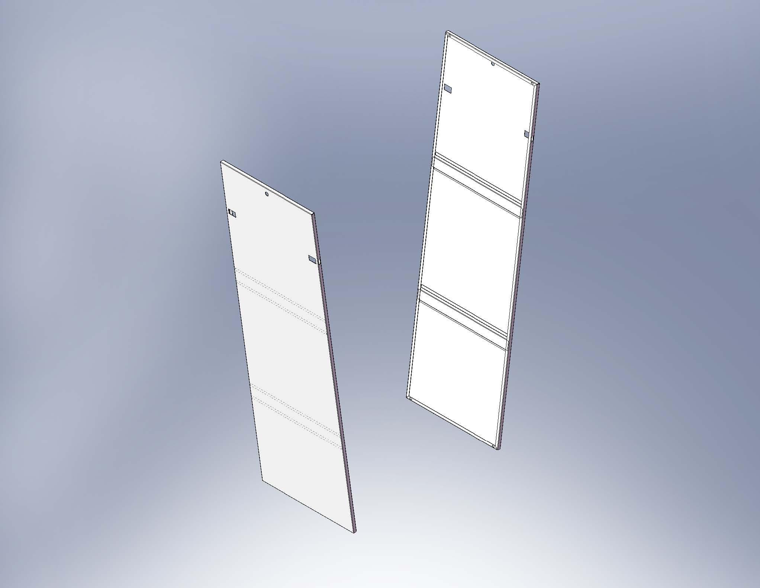 | 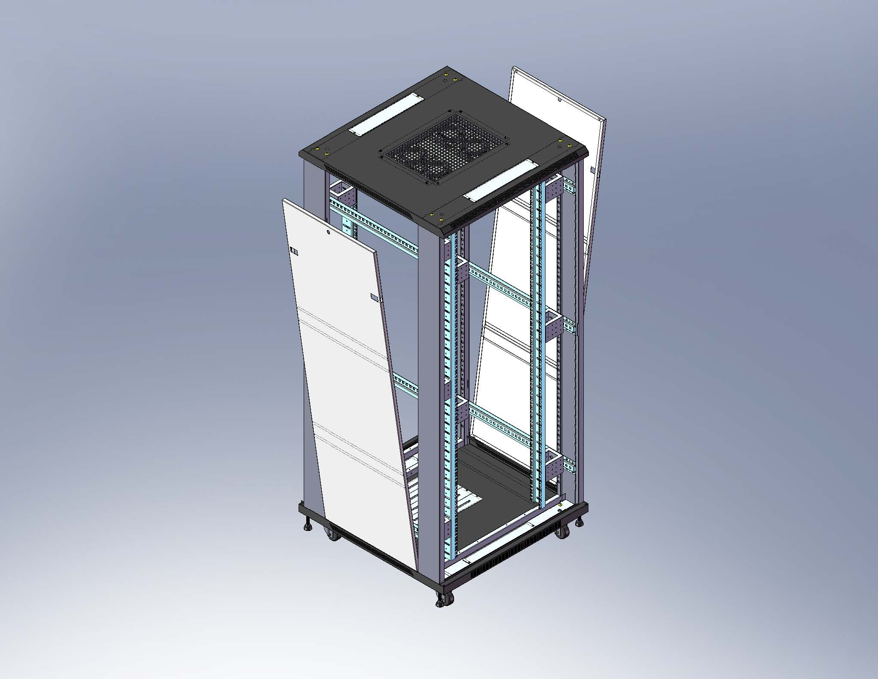 | 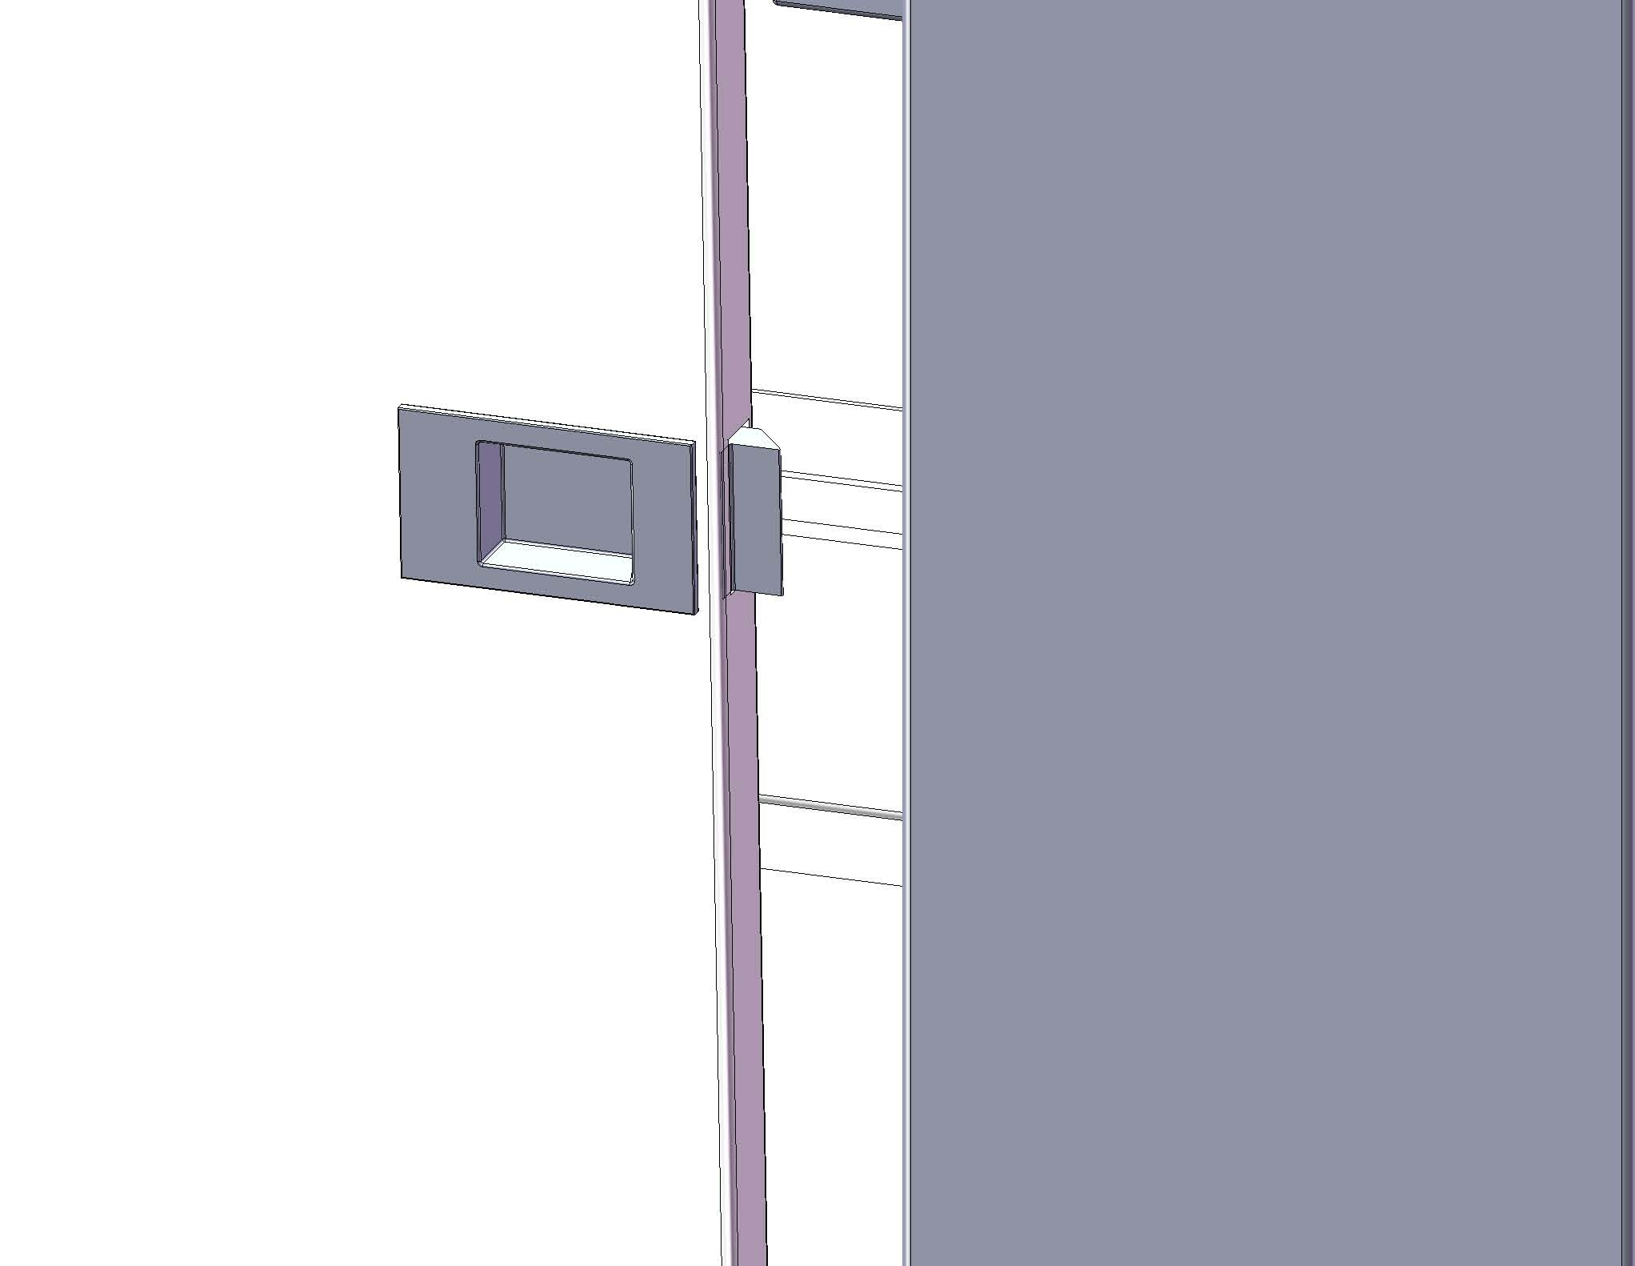
Side panel. (Left side and Right side) | Installing side panels. | Plastic lock for side panel.
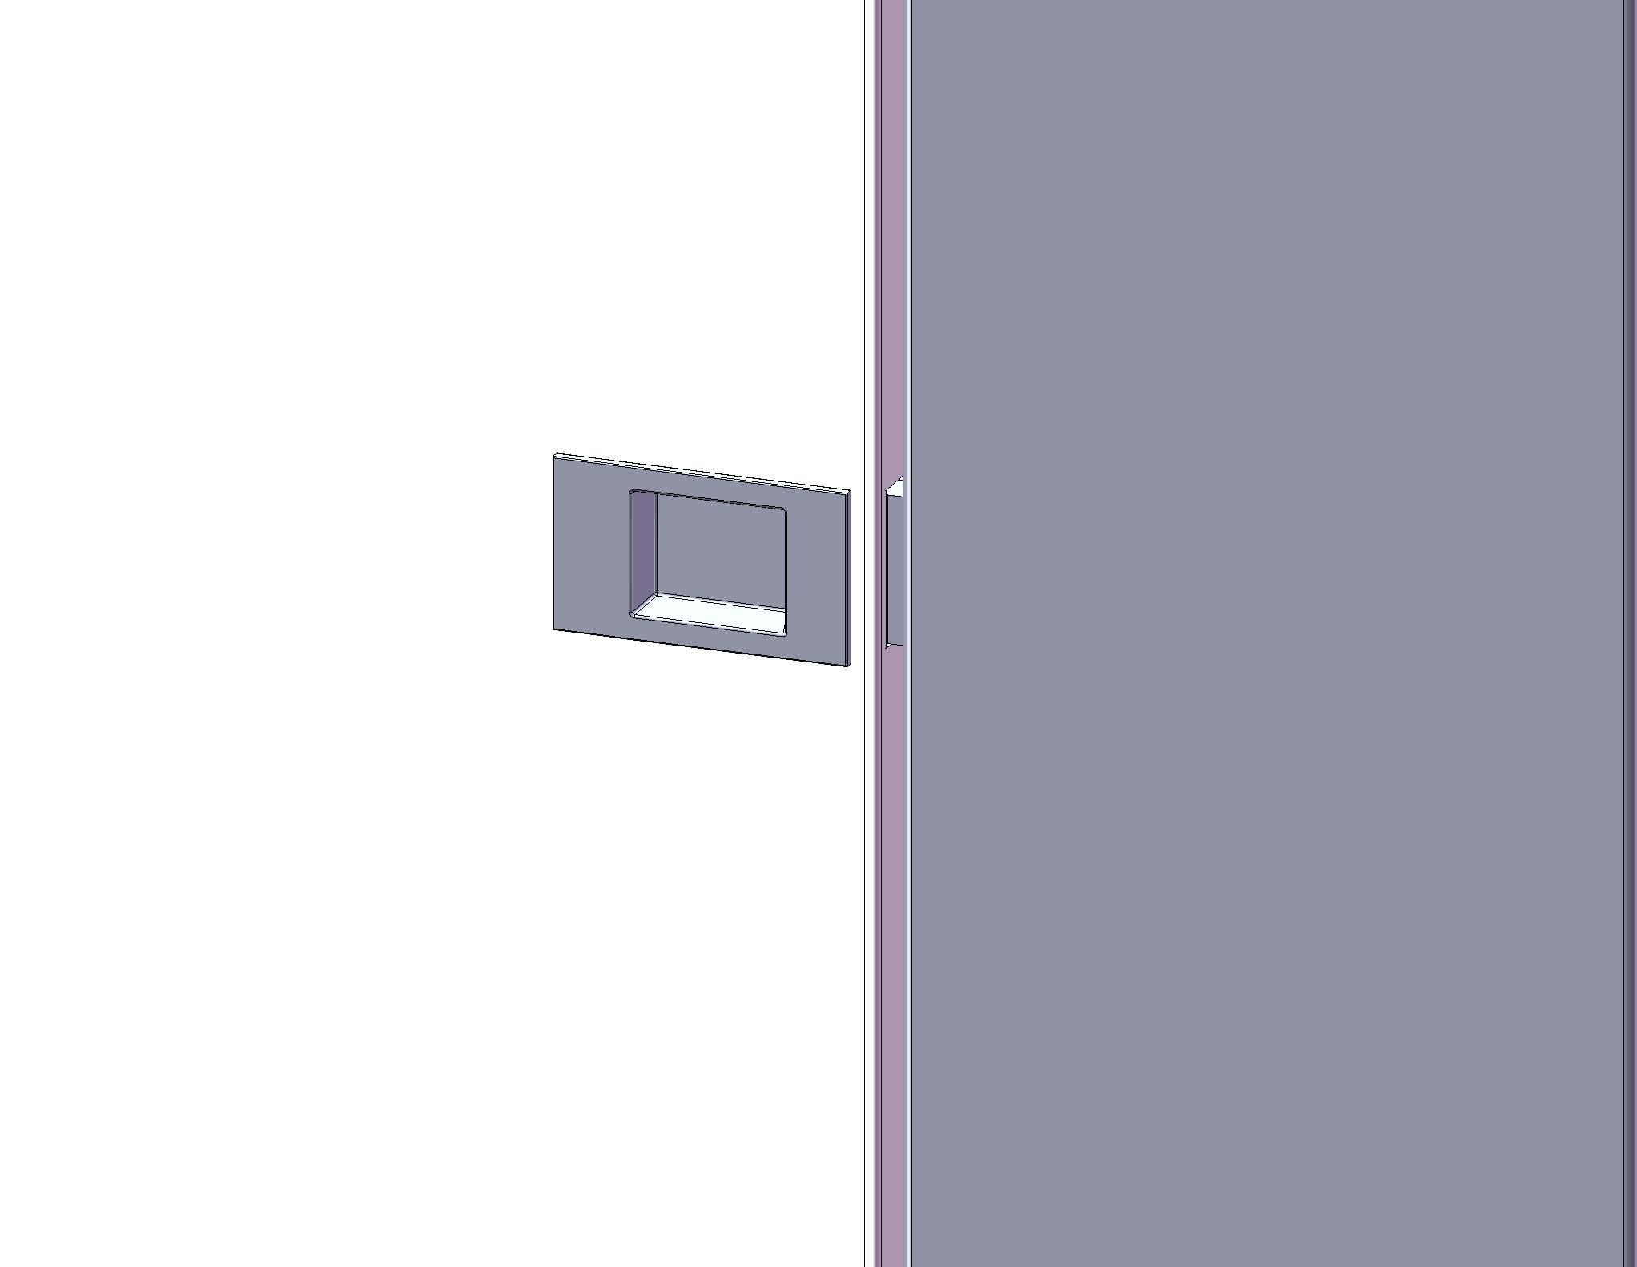 | 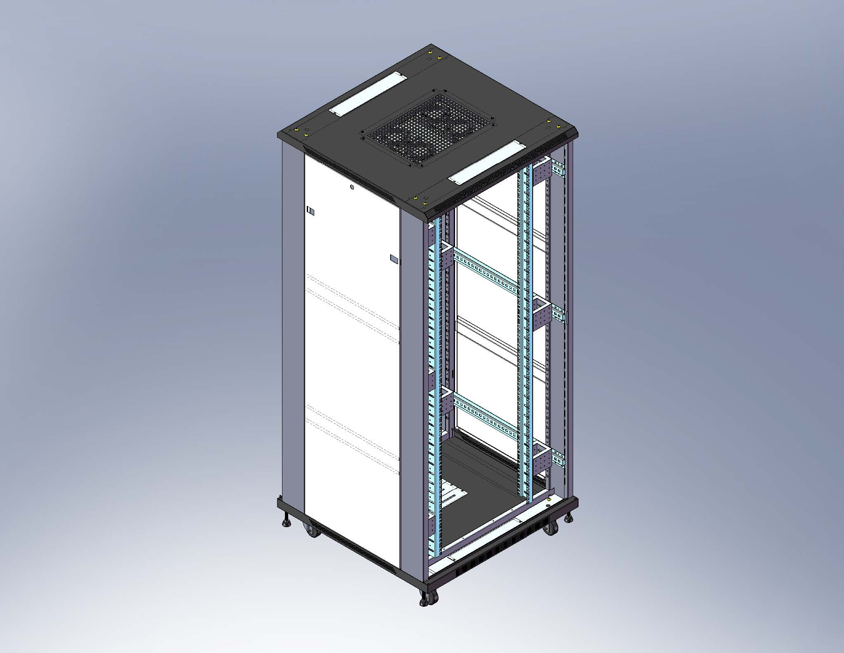 | 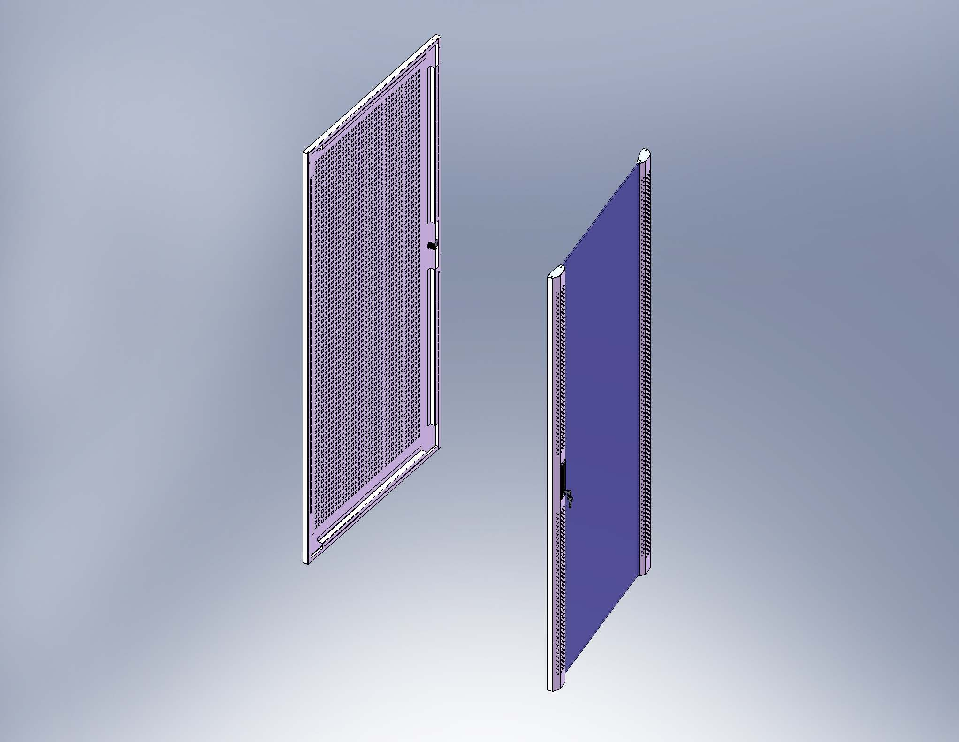
Locking plastic lock into the side panel. | Finish to assemble the side panels. | Front and Rear door.
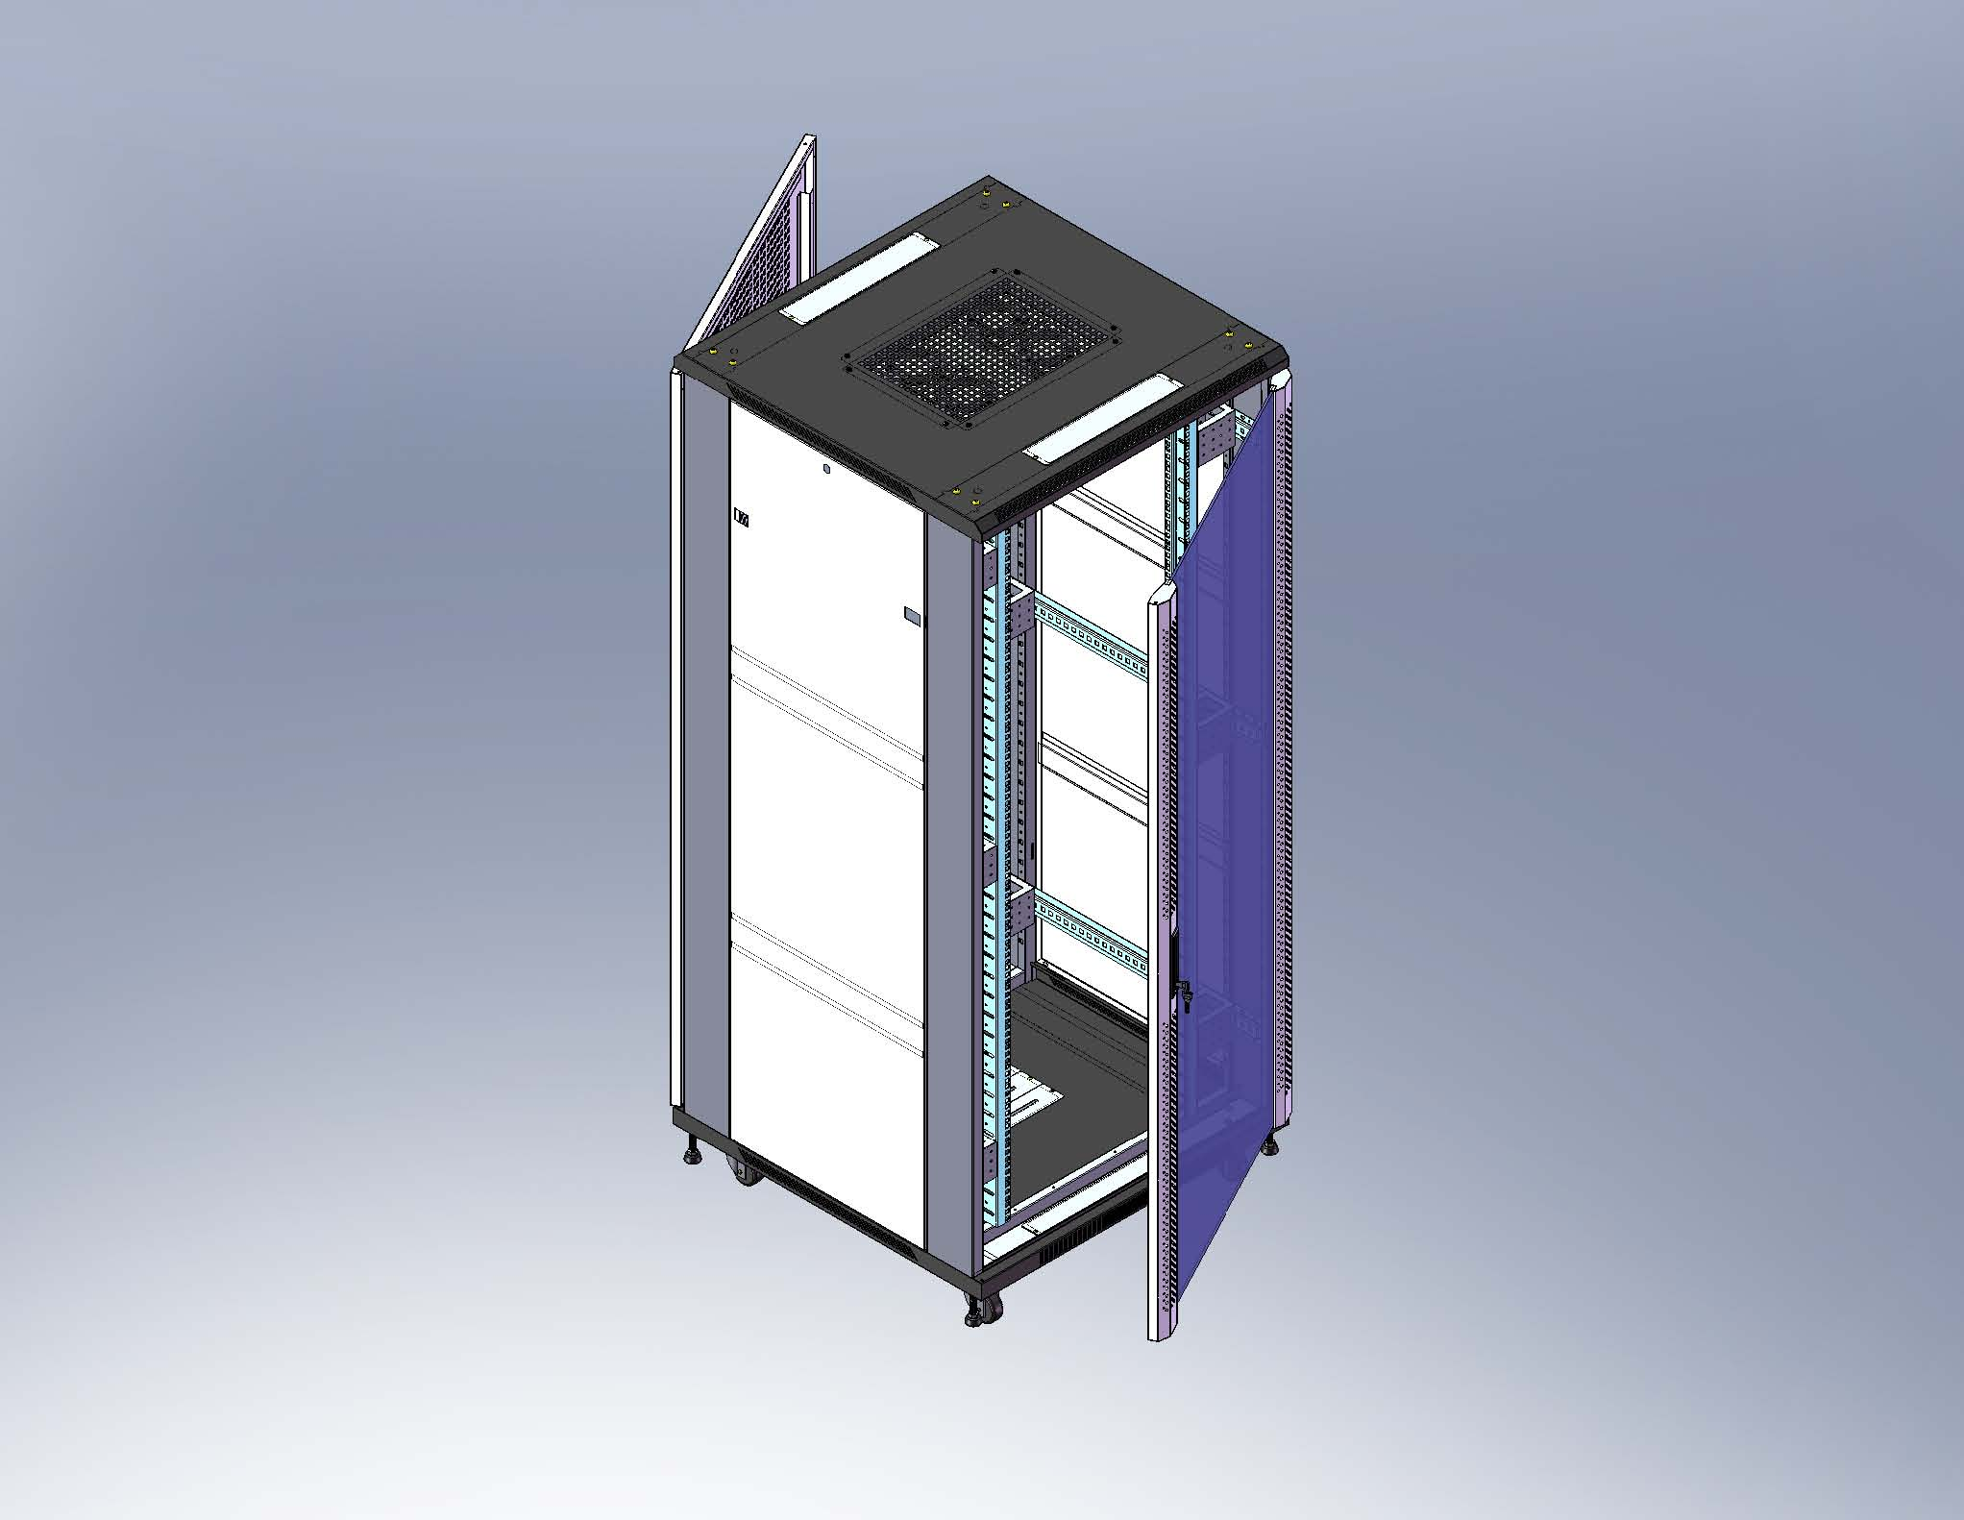 | 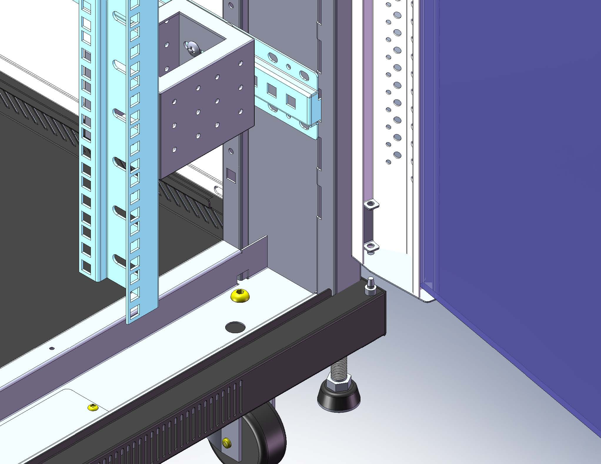 | 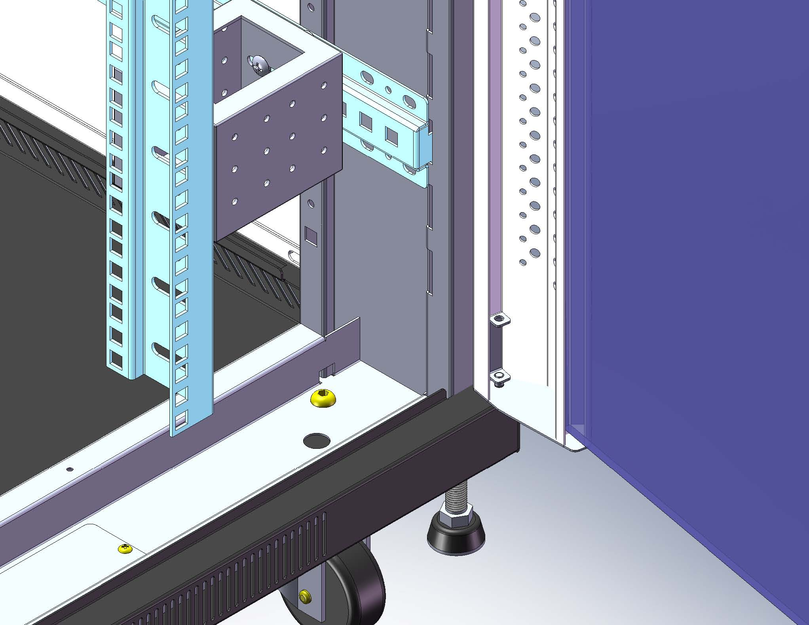
Assemble the front and rear door. | Put the pin on the bottom plate, then use the hinge bolt to contact the bottom plate and front door. | The chart of assemble of drawer set step.
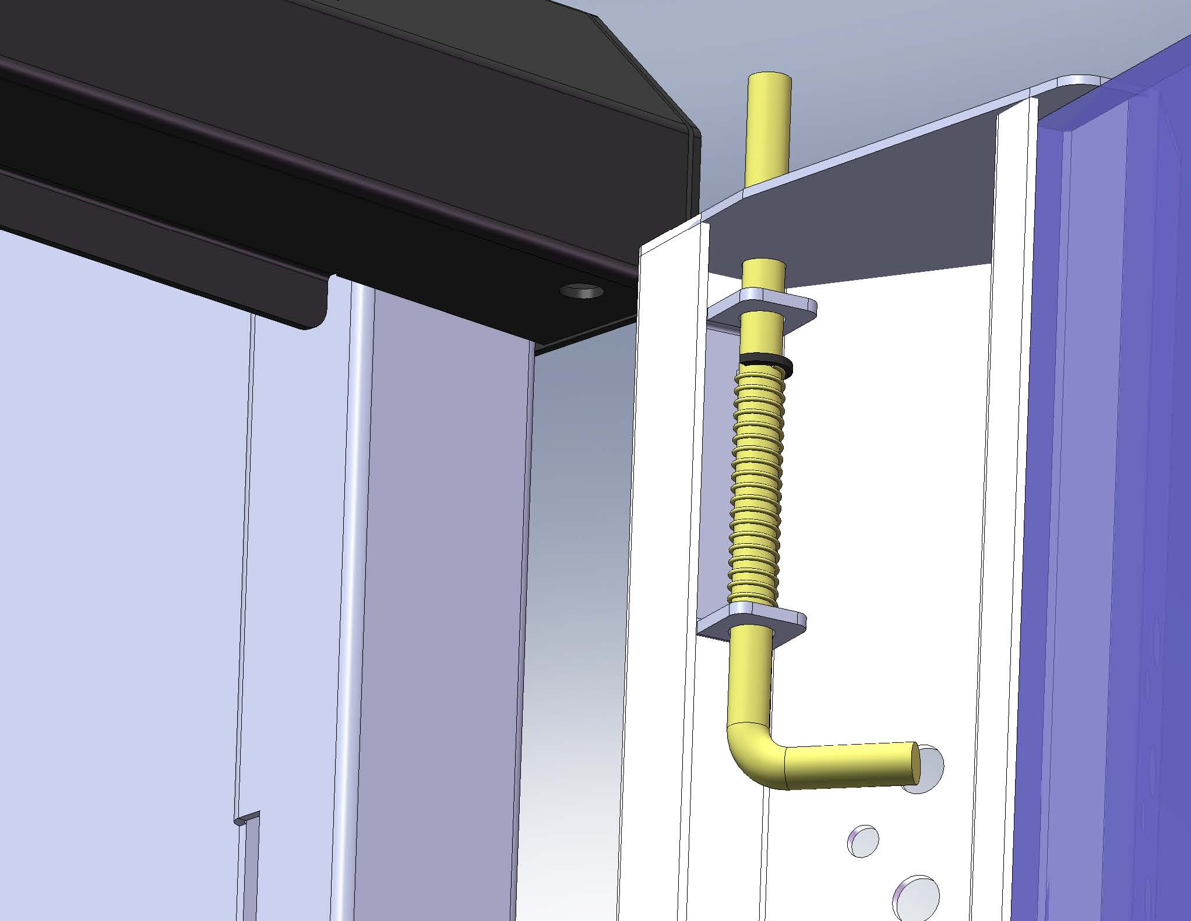 | 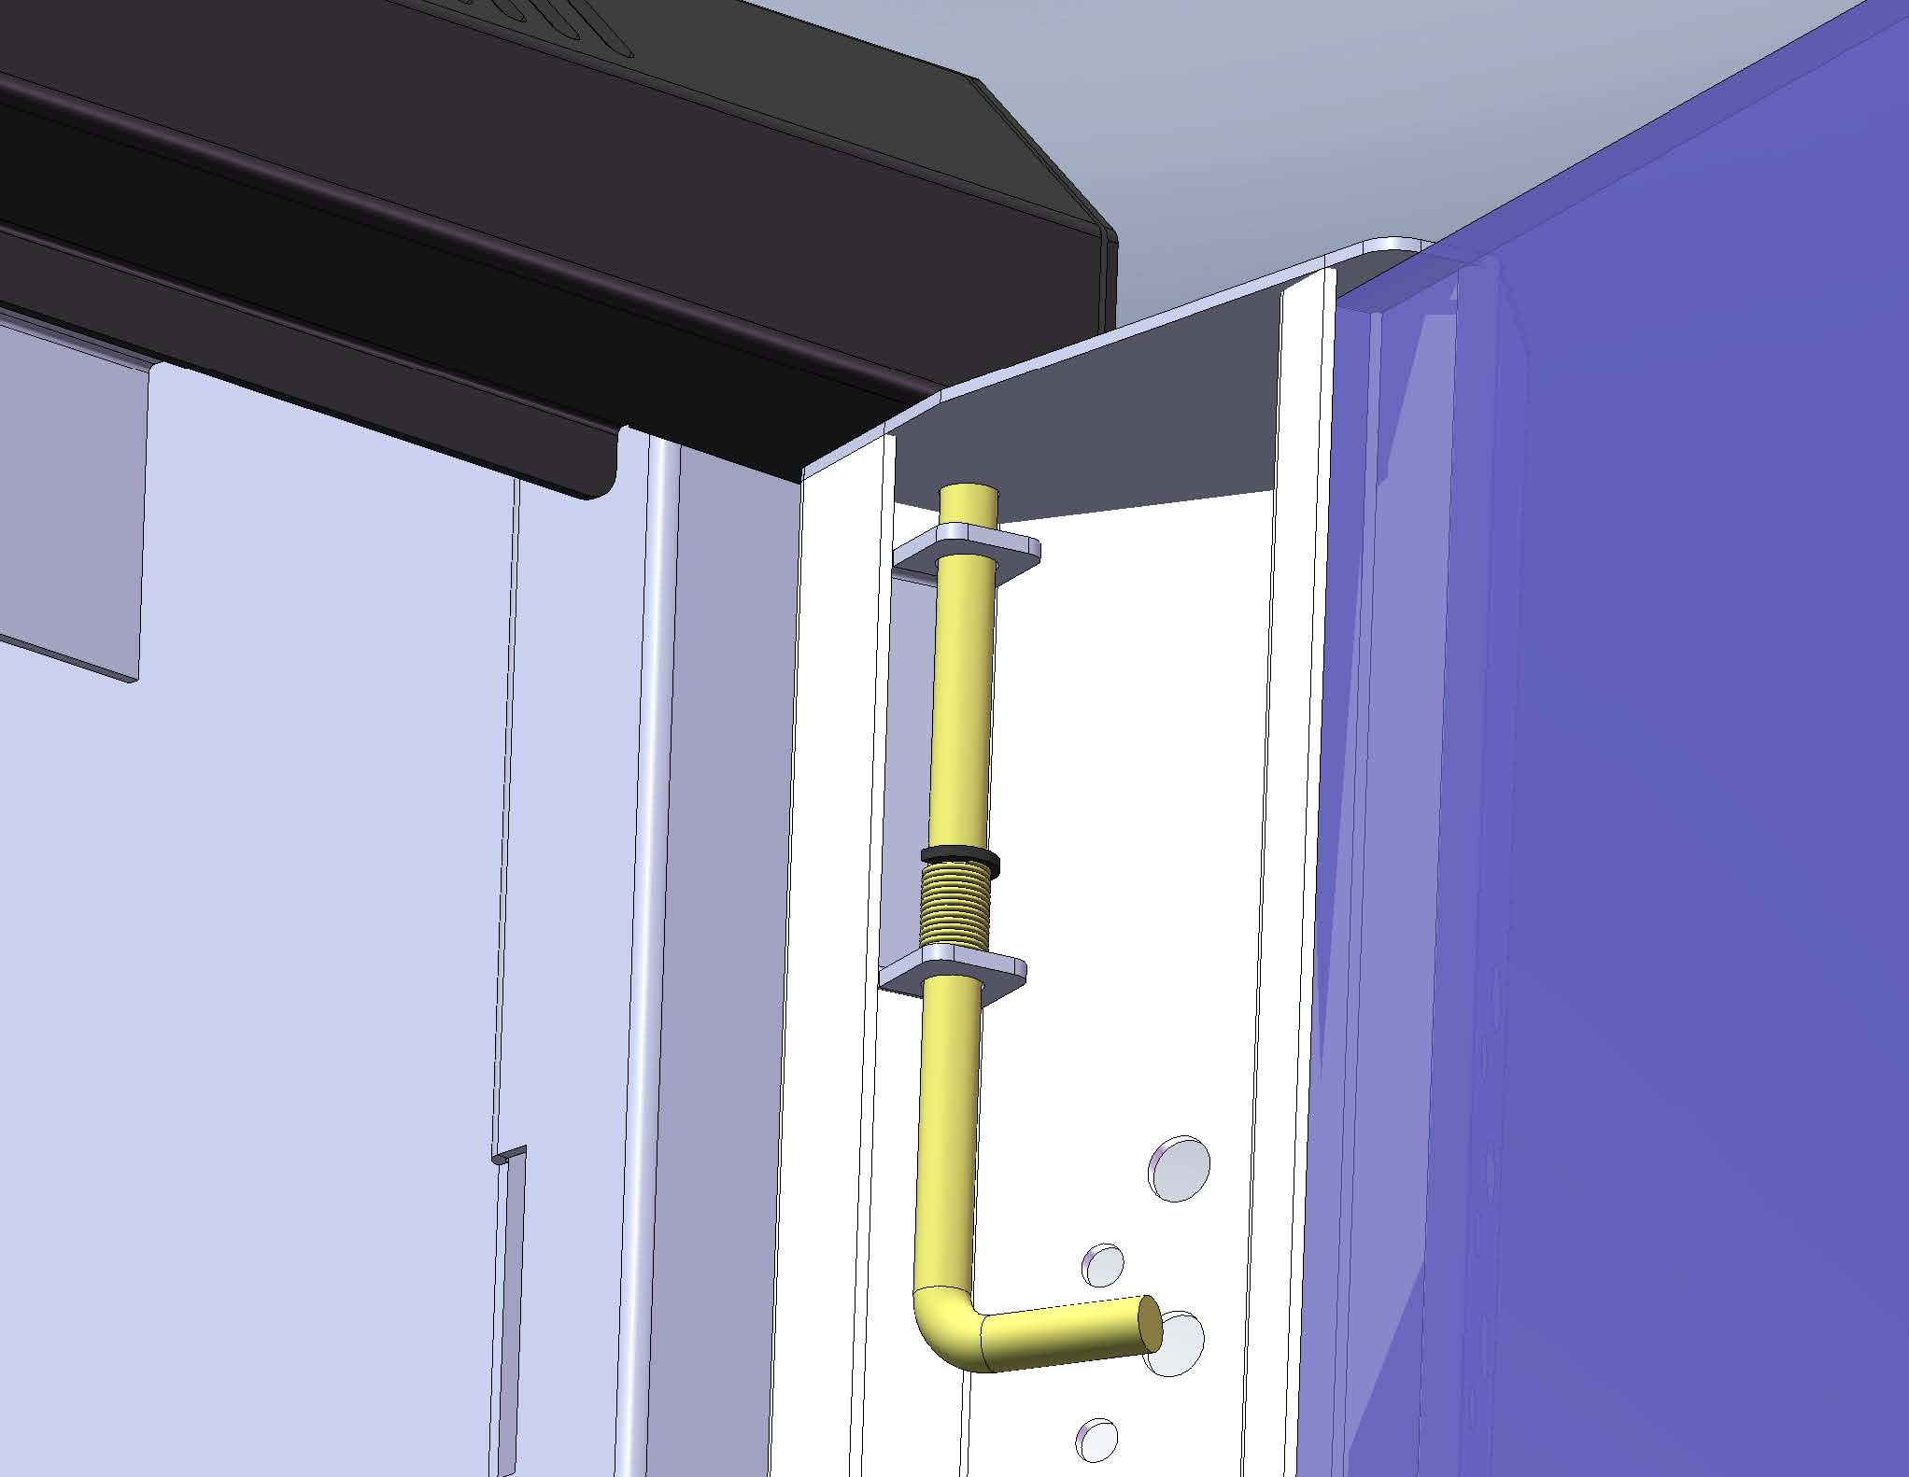 | 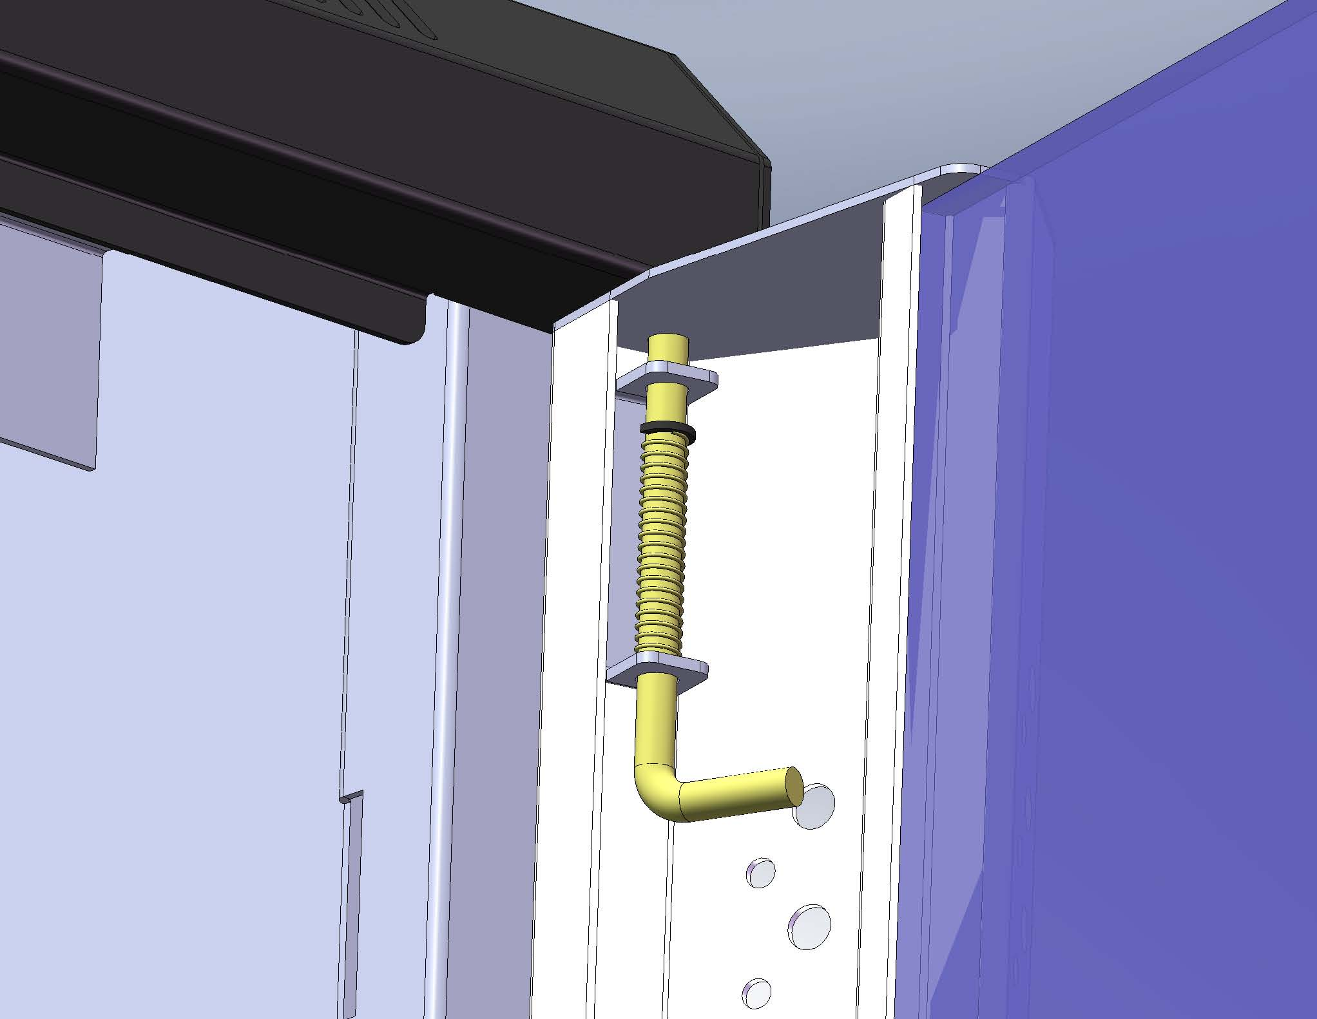
Attached the top section of front door. | Attached the top section of front door. | Attached the top section of front door.
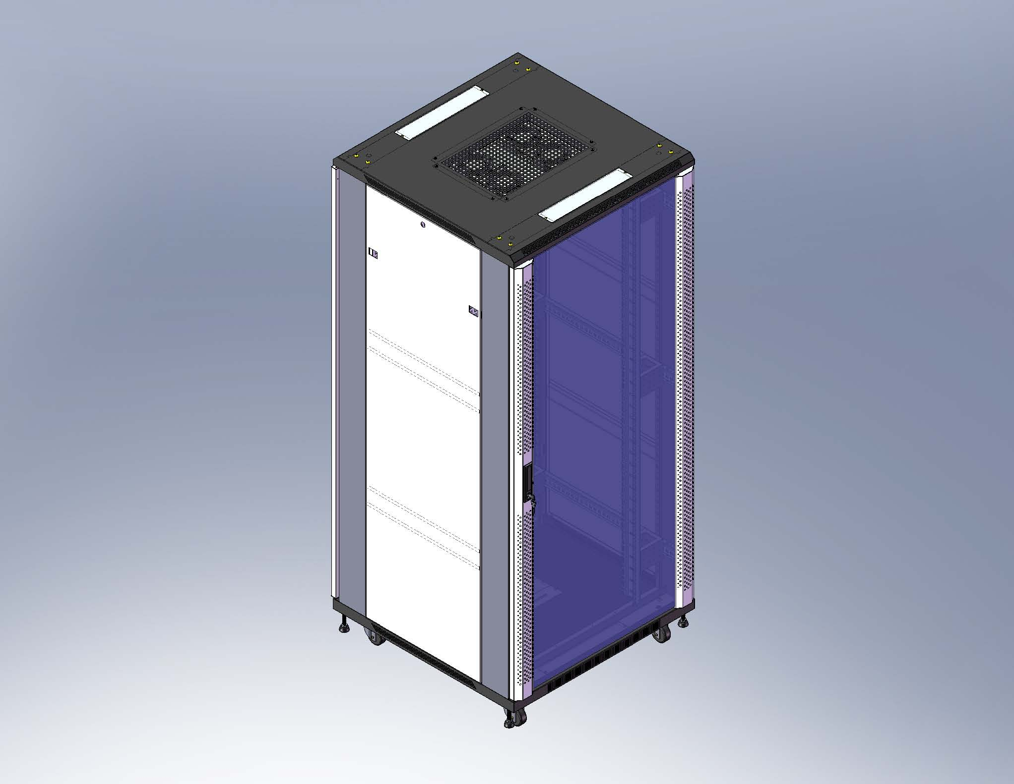 | 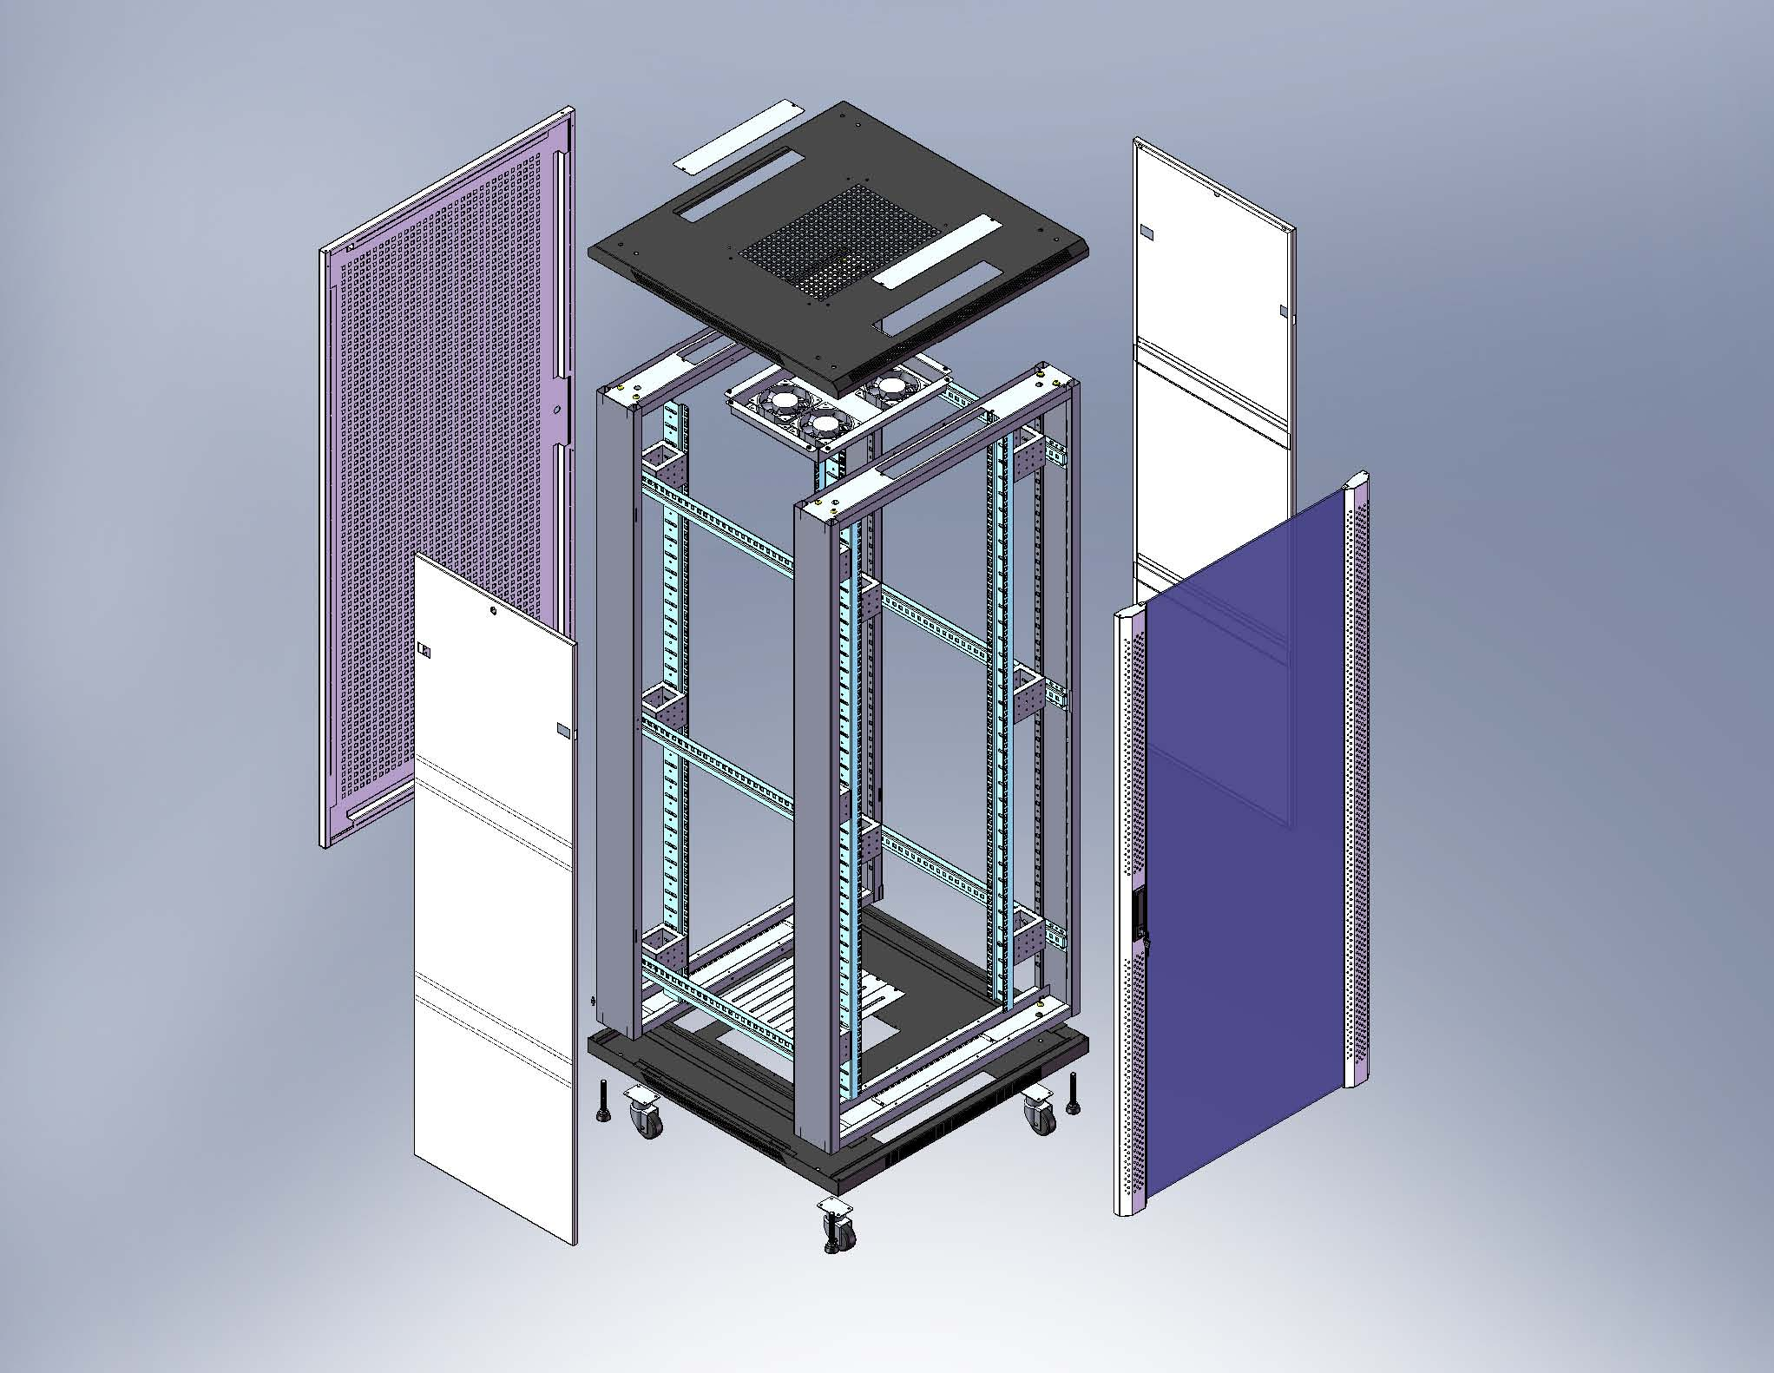
Finish the rack assembly. | Exploded Drawing.

Sever rack Package
CARTON A:
Item | Qty | REMARK
TOP | 1
BOTTOM | 1
HORIZONTAL MOUNTING ANGEL | 6
CABLE ENTRY COVER | 4
CONNECTOR BOX | 12 | FOR 800 WIDTH CABINET
CASTOR | 4
SCREW BAG | 1
FAN TRAY UNIT | 1
CATON B
Item | Qty | REMARK
FRAME | 2
VERTICAL CABLE MANAGEMENT | 2 | FOR 800 WIDTH CABINET
VERTICAL MOUNTING PROFILE | 4
CATON C
Item | Qty | REMARK
FRONT DOOR | 1
REAR DOOR | 1
SIDE PANEL | 2

The screw number would be adjusted in accordance with Cabinet Size
Screws type | Pictures | Spec. | Q’ty | Usage
Round head cross screw | 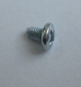 | M5*12 | 4 | *Latch of side panel: 4*1=4
Hex Socket Screw | 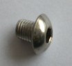  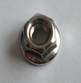 | M8*12 | 16 | *Top cover: =8 screws  *bottom plate: =8 screws
Round head cross screw | 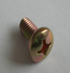  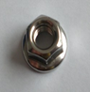 | M6*12 | 66 (W:600mm) or 120 (W:800mm) | - Mounting rail: 6pcs*8 screws=48  - Castors：4*4 screws=16  Only Width 800mm rack: a. Vertical cable management : 2*6=12 screws+2*6=12 Nut  b. Connective block (only Width 800mm rack): 4*12=48 screws
Round head cross self tapping |  | M4*8 | 12 | Top cover and bottom cover: 4 X 2 scrws=8  *Fan tray: 1X4=4
Connected nut | 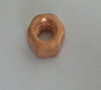  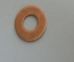 | M6 | 4+4 | *Ground connection

